**Unraveling Genetic Variability and** **Phenotype Expression, Assessing Drought Stress Tolerance & Multi-Trait Stability Index of (*Vigna radiata*) Genotypes in Nepal.**

**Bikas Basneta\***

**Agriculture and Forestry University, Bharatpur, Nepal.**

**Email:** [**bikasbasnet2001@gamil.com**](mailto:bikasbasnet2001@gamil.com)

**\*Orchid id: 0000-0003-0579-6039**

**Abstract:**

Randomized complete block design for 16 mung bean genotypes was employed for multivariate selection & mean comparison was done with Duncan's test (p ≤ 0.05) for yield-attributing traits. This study revealed that four qualitative traits have Shannon diversity index ranging from 0.4152(Pod color) to 0.7484(Terminal Leaf shape). Twelve eigenvalues > 1, contributed 73% of the variability. First three PCs accounted for optimum variances, with 19.25%, 8.39%, and 6.97%. Plant height, root nodules phenotypes, harvesting index associated traits, pod & grain dimension present in all 3 PCs exhibited mean values touched the threshold line. Elbow technique elucidates that 4 major clusters have a dissimilarity coefficient (0.18); the highest intra & sinter-clusters distance is 440.6(I) and 5959.402(I-II) signifies potential for hybridization. Plus, sign cluster bi-plot genotypes (VC-accessions and CN95) unveil strongly correlated yield-related traits (p<0.001, r=0.54-0.99). Duncan's test elucidated that VC6370A has the highest grain yield (2.432ton/ha), followed by CN95 (2.272ton/ha), VC3960A-88(2.264 ton/ha) had the highest SPAD value (66.13). VC6368(46-40-3) is highly heat & drought-tolerant, while VC6370A demonstrates strong root architecture, highlighting its importance for water use efficiency unveils promising candidates for climate-resilient breeding. MGIDI unveils VC6848, VC1973A(SC) & other techniques VC6370A, CN95 emerged as stable & promising candidates for simultaneous improvement.

Keywords**: Phenotypic Markers, Multivariate Selection, Climate-Resilient Breeding, Genetic Variation, Mung-bean.**

1. **Introduction:**

Mung bean is a pulse crop principally grown in the tropic and sub-tropic parts of the world for its nutrient-rich seeds[1]. It has 22(diploid) chromosomes, except for the variety *V. reflexa pilosa*, which has 44(Tetraploid). The experimental variety *V. radiata var. radiata* VC1973A and its relatives has a genome size of 475-579.35 million base pairs[2]–[4]. In Nepal farmers usually grow due to short duration(55-75 days) habbit and its ability to fix atmospheric nitrogen. Mung-bean (*Vigna radiata* L.) is a vital legume crop in Nepal, playing a crucial role in food security and nutrition[5]. It is the strong low cost source of 60-65% carbohydrates, 20.97-31.32% protein, fats and antioxidants reduces aging, iron and folate. However, their culinary potential extends far beyond daal[6]. Mung beans can be processed into a variety of delicious and nutritious products, including: noodles, porridge, curry, ice cream, cakes, soups, flour and livestock feed[7]. Spanning a global area of roughly 7.3 million hectares, mung bean cultivation generates an approximate output of 5.3 million tons worldwide. India and Myanmar stand as the leading producers, contributing nearly 30% each to the global supply. China follows closely with a 16% share, while Indonesia accounts for the remaining 5%. This collective effort ensures that the world's mung bean demands are met(<https://avrdc.org/intl-mungbean-network/>). In Nepal farmers select to cultivate on fertile region is characterized by flat plains and easy access to irrigation. The western Terai and foothills contribute the remaining 25% of mung bean production in Nepal. In total, approximately 12,000 hectares of land are dedicated to mung bean farming across the country. Despite the favorable growing conditions, mung bean yields in Nepal remain relatively low, averaging around 0.6tons/ha(*Krishi Diaray, 2022*). This falls below the global average yield of 2.8 to 3 tons/ha. Several factors contribute to the lower yields in Nepal, including climate crises, limited access to improved varieties, inadequate selection techniques for multiple traits, poor pod and seed setting, and traditional farming practices. Efforts are underway to address these challenges and boost mung bean production in the country.

The integration of multivariate methods and mixed models into genetic divergence evaluation has transformed the field of plant breeding. These powerful techniques provide researchers with a comprehensive understanding of the genetic architecture of plant populations, enabling the identification of superior genotypes with desirable agronomic traits and stable performance across diverse environments. As computational tools continue to advance, the role of multivariate methods and mixed models in genetic divergence evaluation is poised to expand further, propelling the development of high-yielding, climate-resilient crops for a sustainable future[9].Principal Component Analysis (PCA) provides a powerful visualization tool to effectively portray the intricate relationships between key agronomic traits. This graphical representation enables researchers to conduct a holistic assessment of varieties across a spectrum of traits, facilitating the identification of valuable breeding resources and guiding the formulation of effective selection strategies[10]. Grouping of genotypes in biplots was highly congruent with the dendrogram results, indicating the principal component, which accounted for most of the total variance, is the most important trait for selecting the best genotypes[11].

Understanding the genetic differences between various crops and their offspring is crucial for improving plants worldwide. This knowledge helps breeders select the best parents for crossbreeding and create crops with superior traits. While genetic diversity can be assessed in various ways, it often focuses on traits that are affected by the environment[12]. Morphological characterization serves as the cornerstone of genetic improvement programs, laying the groundwork for the meticulous description and classification of crop genetic resources. This fundamental step unveils the extent of genetic variability, a crucial determinant of successful breeding endeavors[7]**.** Plant breeders strive to cultivate superior crop varieties that not only deliver enhanced yield but also exhibit remarkable adaptability and stability across diverse environmental conditions. The pursuit of this ideal variety entails the harmonious convergence of high yield potential with unwavering performance consistency[13]**.** In the face of a rapidly changing climate, modern agriculture faces the dual challenge of simultaneously ensuring food and feed security while minimizing its environmental footprint. Tackling this complex issue necessitates the identification and characterization of superior genotypes, derived from studies that provide profound insights into the interplay between genetics, plant development, and environmental responsiveness[14]**.** As climate change alters traditional crop cultivation practices and regions, it is crucial to consider its impact alongside other factors influencing agricultural productivity, such as evolving farming techniques and technological advancements. In this context, the Multi-Trait Stability Index (MTSI) emerges as a valuable tool for simultaneous genotype selection, offering a robust and user-friendly method that accounts for the correlation structure among traits[15]**.** Selection indexes are a better way to improve selection efficiency because they allow for the simultaneous selection of multiple traits, resulting in genotypes that are closer to the ideal. The biggest drawback of the classic linear selection index is the need to specify the economic weight of each trait, genotypic and phenotypic variances and covariances, and its vulnerability to multicollinearity[16].The stability index proposed by [17] allows for the selection of stable genotypes with favorable selection differentials for traits to be increased and unfavorable selection differentials for traits to be decreased.

Environmental factors significantly impact the expression of morphological markers. Climate crises, particularly drought stress, pose a formidable challenge to crop productivity, including mung beans in Nepalese agriculture. With increasing climate variability, evaluating the drought stress tolerance of mung bean genotypes becomes paramount for sustainable agriculture in Nepal. Delving into the intricate interplay between genetic factors and environmental stressors is essential for identifying and characterizing genotypes that exhibit resilience in the face of drought. While seed yield remains a critical parameter in mung bean breeding, overreliance on this metric alone for selecting superior genotypes can be misleading and ineffective. Previous studies have demonstrated that selection based solely on yield may overlook crucial traits that contribute to overall crop performance and adaptability. This narrow approach can lead to the development of high-yielding varieties that are susceptible to environmental stresses or lack desirable consumer qualities. Additionally, the significant gap between farmers' fields and research stations in Nepal highlights the need for breeding strategies that bridge this divide. A range of agronomic and morphological traits, if exhibiting significant genetic variability, are suitable for genotype selection. Therefore, this study employed multivariate selection techniques like principal component analysis (PCA), multi-traits stability index (MTSI), and cluster analysis to effectively discriminate genotypes based on specific desirable traits. This study aims to explore the genetic variations in mung bean traits and identify superior genotypes that consistently produce high yields under both optimal and stress conditions. By evaluating mung bean performance in both field and stress environments, this research seeks to develop resilient and high-yielding mung bean varieties that can adapt to the changing climate.

1. **Materials and Methods**
   1. **Source of mung-bean germplasm:**

The germplasm utilized in this study comprised 13 exotic mung-bean genotypes and three promising cultivars. The exotic genotypes were sourced from the Grain Legumes Research Program at NARC (Nepal Agricultural Research Council) in Khajuria, Bake, Nepal. A significant portion of these exotic collections was acquired from Taiwan. The genotypic information of the germplasm is presented in **Supplementary file (S1).**

* 1. **Experimental site & design**

The experiment was carried out during the summer season, spanning from March 22 to June 7, at the Agriculture and Forestry University (AFU), Rampur, agronomy research Unit. The field experiment was designed using a Randomized Complete Block Design (RCBD) with a single factor, involving 16 different mung-bean germplasm treatments. These treatments were replicated three times, and two blocks were established perpendicular to a fertility gradient within the single replication. Each individual plot measured 4.62 square meters, with dimensions of 2.8 meters by 1.65 meters. In each plot, there were seven rows, and each row contained 11 plant spots, with dimensions of 40 by 15 centimeters (40 × 15-RR×PP), resulting in a total of 77 plant spots per plot Figure 1. The entire research area covered 430 square meters, with dimensions of 27.9 meters by 15.4 meters. To prepare the field for sowing, it underwent two rounds of harrowing and concurrent leveling to ensure uniformity. Fertilizers were applied as recommended, with 500 kilograms of farmyard manure (FYM) per hectare added three days before sowing. Additionally, Nitrogen, Phosphorus, Potassium (N, P, K) were applied at rates of 20:40:20 kilograms per hectare, five hours before sowing. The first weeding operation was conducted 15 days after sowing, followed by another weeding before the onset of flowering. In response to severe drought conditions, a single round of flooding irrigation was administered three days before sowing and Irrigation was withheld during approximately 50% of the flowering phase due to rainfall occurring 53 days after sowing.

Seeds were sown on March 22 to get the optimal yield, as detailed by [18]. To achieve germination synchronization, the seeds underwent hydro-priming, where 100 grams of seeds were soaked in a water solvent at a 1:1 weight-to-volume ratio for six hours, maintaining a controlled temperature of 25±1°C. described by [19].

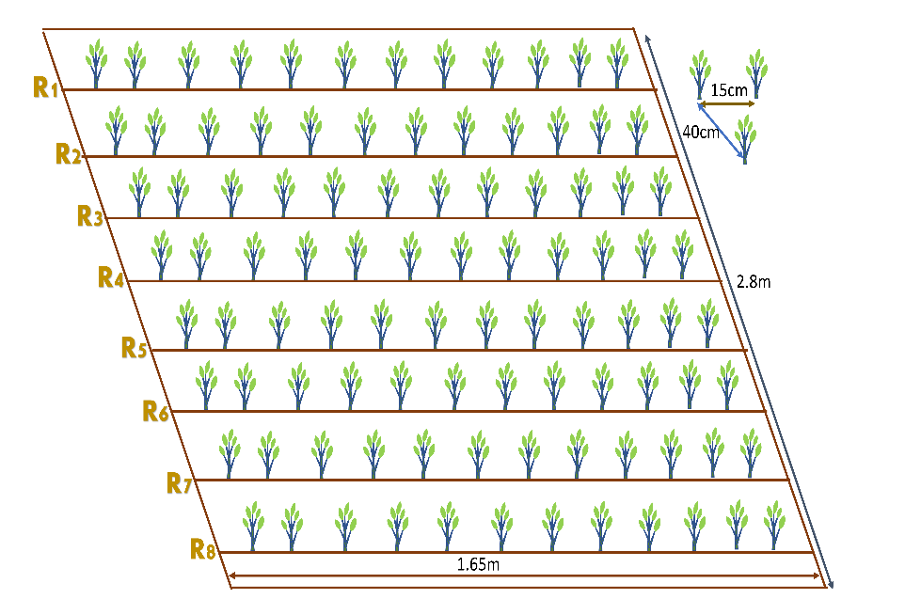

Figure 1 Representation of the Experimental demo plot and GIS map of the Research site

* 1. **Soil Properties and Observed traits**

Based on the soil data of the experiment site, the soil is sandy loam with an acidic pH of 5.52. The soil has medium organic matter content (3.42%), medium total nitrogen content (0.20%), medium total phosphorous content (10.5 ppm), and low total potassium content (5.5 ppm) Table 1.

Table 1 Methods for examining soil properties at the research site.

|  |  |  |  |
| --- | --- | --- | --- |
| S.N | Soil Property | Value/Rating | Method of Extraction |
| 1 | Sand% | 49.3 | The textural triangle of USDA |
| 2 | Slit% | 34.9 | The textural triangle of USDA |
| 3 | Clay% | 15.8 | The textural triangle of USDA |
| 4 | Textural Class | Sandy Loam | Determined by Marshall’s triangular coordinates by USDA system |
| 5 | PH | 5.52(Acidic Nature) | Digital pH Meter |
| 6 | Organic Carbon% | 3.201 | 58% of OM = Organic Carbon |
| 7 | Organic Matter | 3.42(medium) | (1-S/B)0.6810=3.42 because I have 11.6 and 23.4 value of S and B. (Walkley and Black method) |
| 8 | Total N% | 0.20(Medium) | Micro-K-jeldal Method |
| 9 | Total Phosphorous | 10.5 ppm(medium) | Modified Olsen's Bicarbonate Method |
| 10 | Total Potassium | 5.5ppm(low) | Flame photometer method |

* 1. **Meteorological features of the study site**

The weather parameters were recorded at the weather station of the National Maize Research Programme (NMRP) in Rampur, Nepal, 500 meters away from the research station. The 3-year weather pattern for the mung bean cultivation season is given **Figure 2**.

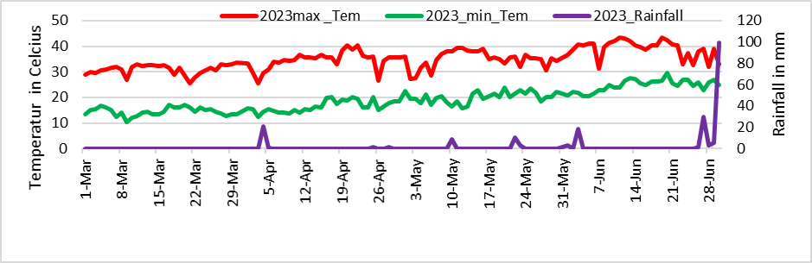

**Figure 2 Evaluating Meteorological Data of Research Stations from Weather Stations**

* 1. **Model of the SPADE (Soil Plant Analysis Development Meter)**

This involves the determination of the Chlorophyll content index for a specific leaf surface area *Figure 3*. The values obtained from leaf measurements are typically unit less and are commonly represented in SPAD units, or in the case of the Minolta SPAD-502, as the percentage transmittance ratio, which corresponds to the Chlorophyll Content Index (CCI) [20][21].

$$CCI=\frac{{Percentage Transmission of IR}_{(931)}}{{Percentage Transmission of RED}_{(653)}}=\frac{{{I^{'}}_{IR(931)}}/{I_{IR(931)}}}{{{I^{'}}_{RED(931)}}/{I_{RED(931)}}}……$$

$$SPAD=K*\log_{10}{(\frac{{\% transmission IR}_{\left(940\right)} }{{\% transmission R}_{ED\left(640 or 650 \right)} }}+ C= K*\log{CCI}+C$$

Where, ${I^{'}}_{IR(931)}$ and ${I^{'}}_{RED(931)}$ are the measured leaf light transmission intensities at the specific (in each measurement) infrared and red wavelengths and $I_{IR(931)}$ and $I_{RED(931)}$ are the light intensities of the **Infra-Red light** source and the **Red Led light** source. By calibrating the SPAD meter against a reference technique for detecting chlorophyll concentration, such as chemical extraction, the calibration coefficient, k, and the constant, C, are established. The wavelength of light is indicated in nano meters (nm) in the equations above by the numbers enclosed in parentheses.

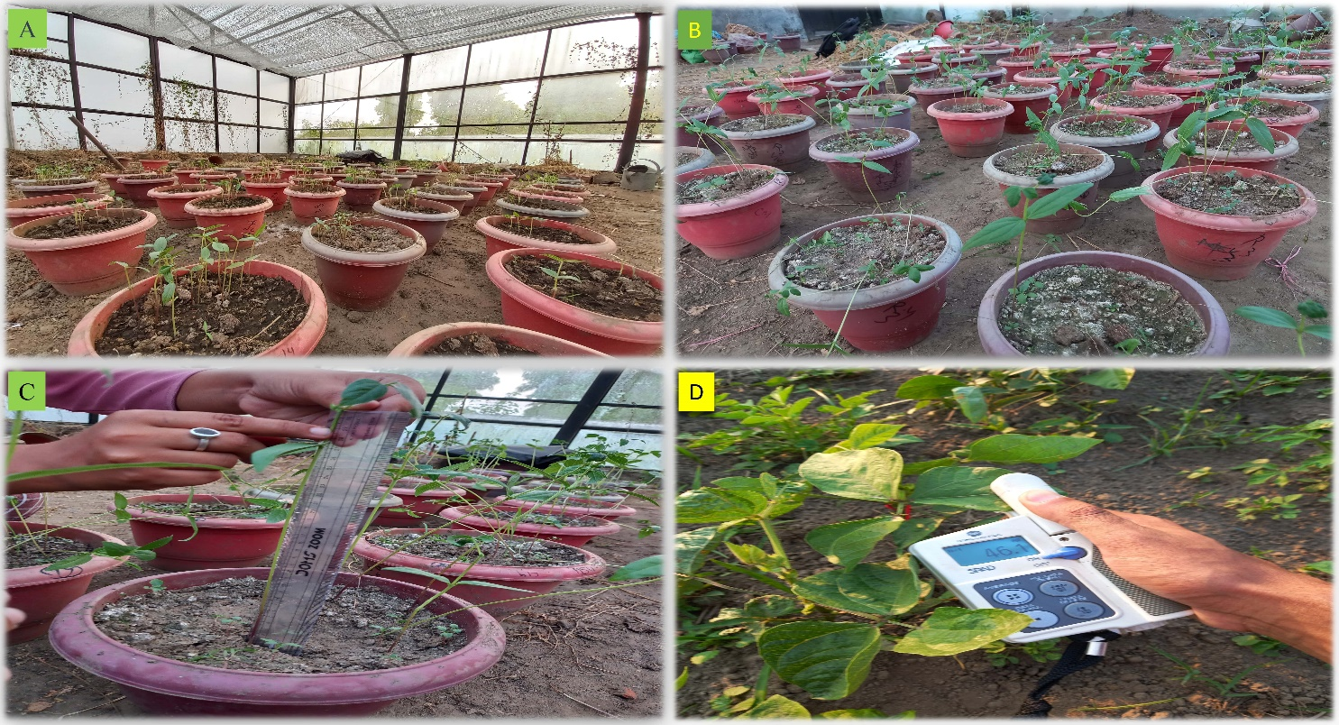

Figure 3 Photographs depicting key stages of a rainout experiment on mung bean seedlings: A) Experimental rainout setup at 10 days after sowing (DAS), B) Mung bean seedlings under rainout conditions at 20 DAS, C) Data collection process at 21 DAS, and D) SPAD meter measuring chlorophyll content in mung bean plants under field conditions

**Calculation model for Shannon Diversity Index**

A greater Shannon Diversity Index signifies increased diversity, whereas a reduced index suggests diminished diversity. Following formula is used to calculate the diversity index **(**[**https://www.omnicalculator.com/ecology/shannon-index**](https://www.omnicalculator.com/ecology/shannon-index)**).**

$$H=-\sum_{i=1}^{S}{p_{i}}\ln_{(p_{i})}…………………………………………………………………………$$

where:

* *H* is the Shannon Diversity Index,
* *S* is the number of different categories,
* *pi*​ is the proportion of individuals in the *i*th category.
  1. **Measurement of the crop water Status**

This study measured the relative water content, water saturation deficit, water retention capacity, and water uptake capacity of various plant samples using a standardized protocol[22]**.**

………………………

* 1. **Multiple Traits Correlation analysis among the morphological markers**
     1. **Pearson correlation coefficient (r) Model**

The correlation coefficient, denoted as 'r,' quantifies the strength and direction of the linear relationship between two variables. It falls within the range of -1 to 1, with a value of 0 signifying the absence of a linear relationship. The following equation is employed for the correlation analysis of Mung-bean descriptors[23].

$r=\frac{\sum_{i=1}^{n}{(X_{i}}+\overline{X})(Y-\overline{Y} )}{\sqrt{\sum_{i=1}^{n}{(X_{i}}}-\overline{x})\sqrt{\sum_{i=1}^{n}{{\left(Y_{i}-\overline{Y} \right)}^{2}}}} ……………………………………………$

Where, $X_{i}$ and $Y_{i}$ are individual data points and $\overline{x}$ and $\overline{Y}$ are the means of ***X*** and ***Y***, respectively.

* 1. **Yield Calculation Model**

The grain yield per hectare for each genotype was calculated from the net plot yield, taking into account the moisture content of the grain. The moisture content of plots was measured using an automated moisture meter, and the final grain yield was adjusted to a moisture level of 10% using the following formula[24].

$Grain Yield \left(\frac{Kg}{ha}\right)=\frac{\left(100-MC\right)*Plot Yield*1000\left(m^{2}\right)}{\left(100-10\right)*net plot area\left(m^{2}\right)}……………………$*..*

The moisture content (MC) is expressed as a percentage of the grain's weight. The straw yield was determined by subtracting the grain yield from the total biological yield (measured in kilograms per hectare). After completely sun-drying the harvested produce, the weight of grain and straw from each plot was recorded separately using a spring balance, and the measurements were noted in kilograms per plot. Subsequently, the per-plot biological yield was converted to kilograms per hectare. The collective yield of all plant materials is referred to as the biological yield, and the ratio of grain yield to biological yield is known as the harvest index, as defined by[25].

* 1. ***Cluster Analysis of Mung Bean Genotypes and Promising Cultivars***
     1. **Euclidean distance Calculation and Cluster Analysis.**

Euclidean distance serves as a widely adopted metric for gauging dissimilarity in cluster analysis. It is formally defined as the square root of the summation of squared disparities between corresponding elements of two vectors, x and y, across multiple dimensions. In essence, the smaller the Euclidean distance between two data points, the more akin they are. Consequently, data points positioned closely together in Euclidean space are predisposed to sharing the same cluster. K-means clustering, on the other hand, represents a straightforward yet efficient algorithm for partitioning data points into a predetermined number of clusters. This iterative procedure hinges on assigning data points to the cluster whose centroid is nearest to them. The centroids, in this context, are the average values of data points within each cluster. In this specific study, K-means clustering was employed subsequent to the calculation of Euclidean distances governed by following equation(Backer et al; 1988)

* + 1. **Genotype analysis by mixed-effect models**

Analysis of genotypes in single experiments using mixed-effect models with estimation of genetic parameters.

$$Y_{ij}=m+g_{i}+r_{j}+e_{ij}………………………………………………………………….$$

Where, $Y_{ij}$  is the response variable of the ith  genotype in the *j*th block/replications; *m* is the grand mean (fixed); $g_{i}$  is the effect of the *i*th genotype (assumed to be random); $r_{j}$ is the effect of the *j*th replicate (assumed to be fixed); and $e_{ij}$  is the random error. the BLUP model is used to estimate the genetic values of the genotypes for each trait in multi-trait genotype-ideotype distance index calculation. The multi-trait genotype-ideotype distance index is a method used to select genotypes in plant breeding programs based on multiple traits, and it is calculated as the Euclidean distance between the scores of the genotypes and the ideal genotypes.

* + 1. **Multi-Trait Genotype-Ideotype Distance Index (MTGID)**

Multivariate data in biological experiments are important for better treatment recommendations or genotype selection. Classical linear multi-trait selection indexes may not be effective due to multicollinearity and arbitrary weighting coefficients. A new approach called the MGIDI uses distance between genotypes/treatments and an ideotype to select unique, easy-to-interpret options without these issues. This concept is used in plant breeding and can improve the efficiency of selecting for multiple traits[26][14], [15].

$${\dot{MGIDI}}_{i}=\sqrt{\sum_{j=1}^{f}{{\left(Fij-Fj\right)}^{2}……………………………………………………}}$$

Where ${\dot{MGIDI}}_{i}$**=** index of multi-trait genotype-ideotype distance for the ith genotype. $F_{ij}$ represents the score assigned to a given genotype in relation to a specific factor, denoted by "i" for the ith genotype and "j" for the jth factor. The variables g and f correspond to the total number of genotypes and factors included in this analysis, $F_{ij}$ is the **jth** score of the ideotype. The genotype exhibiting the lowest MGIDI is more proximate to the ideotype and, consequently, is expected to showcase desirable values for all scrutinized traits.

The relative contribution of each factor to the MGIDI index for each genotype can be used to identify the strengths and weaknesses of those genotypes.

* + 1. **FA (Factor analysis) -BLUP (Best Linear Unbiased Prediction) Index Calculation**

1. **Rescaling the Traits**

Consider Xij as a table consisting of i rows representing genotypes or treatments, and j columns representing traits. To obtain the rescaled value for the ith row and jth column (rXij), use the following formula[27]:

${rX}_{ij}=\frac{{Max}_{nj}-{Min}_{nj}}{{Max}_{oj}-{Min}_{oj}}*(∅_{ij}-{Max}_{oj})+{Max}_{nj}$,………………………………………..

Where ${Max}_{nj}$ and ${Min}_{nj}$ represent the updated maximum and minimum values for trait j following the rescaling process**, ${Max}_{oj}$** and ${Min}_{oj}$ represent the uppermost and lowermost limits of trait j, respectively. Meanwhile, $∅_{ij}$ is indicative of the initial value for the jth trait belonging to the ith genotype. To achieve negative gains in desired traits, it is recommended to utilize the values of ${Max}_{nj}$ = 0 and ${Min}_{nj}$ = 100. For desirable traits, the maximum value of ${Max}_{nj}$ set to 100 while the minimum value of ${Min}_{nj}$ is set to 0 in the re-scaled two-way table (rXij). This leads to each column exhibiting a range spanning from 0 to 100, which considers the intended direction of selection (either increase or decrease) and maintains the original correlation structure of the variable.

1. **Factor Analysis**

A statistical technique known as the factor analysis model is used to express variation among connected, observable variables in terms of a possibly smaller set of unobserved variables known as factors. The following formula can be used to express the factor analysis model:

X = μ + LF + ε

Factor analysis identifies underlying factors that explain correlations among observed variables. X is the vector of measurements, μ is the vector of means, L is a matrix of loadings, F is a vector of common factors, and ε is the vector of unique factors. Eigenvalues and eigenvectors are obtained from the correlation matrix of rXij. Initial loadings are based on eigenvalues higher than one. Varimax rotation criteria are used for analytic rotation and estimation of final loadings. Scores are obtained accordingly.

$$F={Z(A^{T}R^{-1})}^{T}....................................$$

The matrix F contains the scores for factorial analysis, while Z is a matrix of standardized means that have been rescaled. A represents canonical loadings in a matrix with p rows and f columns, and R is a correlation matrix between traits with dimensions p by p. The variables g, f, and p denote the number of genotypes or rows analyzed, factors retained during analysis, and traits studied respectively.

1. **Spatial Probability Calculation:**

Genotype-Ideotype distance is used to rank genotypes by estimating spatial probability. The FAI-BLUP index uses a Markov chain to calculate the probability of transitioning between states based on genotype distance and an ideotype. Closer states have a higher probability of transitioning. This index identifies underlying factors for balanced genetic gain and easy selection process. The subsequent mathematical formula is employed to compute the likelihood of spatial occurrence:

$$P_{ij}=\frac{\frac{1}{d_{ij}}}{\sum_{i=1, j=1}^{i=n;j=m}{\frac{1}{d_{ij}}}}……………………………………………………$$

In which Pij is the likelihood that the ith genotype (i = 1, 2,..., n) will resemble the jth ideotype (j = 1, 2,..., m); and dij is the distance between the ith genotype and the jth ideotype based on the standardized mean Euclidean distance.

* 1. **PCA analysis data**

PCA uses eigenvectors and eigenvalues to identify the principal components of data. Eigenvectors determine new feature space directions while eigenvalues determine their magnitude and explain the amount of variation in the data. The data is transformed into a centered matrix and decomposed into eigenvalues and eigenvectors. Sorting eigenvectors by eigenvalues provides a ranking of components for the new subspace. PCA creates new variables, called principal components, by combining the original variables in a way that preserves as much of the information as possible. The importance of each principal component is determined by its eigenvalue.

* + 1. **Empirical covariance and Gram matrices.**

To initiate a Principal Component Analysis (PCA) on a data matrix, Y, comprising of n rows and L columns, the primary step is to convert Y into a centered matrix Z by adjusting the mean value of each column to zero. The empirical covariance matrix is then defined as an L*L matrix.

$$C=\frac{1}{n}Z^{T}. Z……………………………………………………………………………………………………..$$

Occasionally, an unbiased estimator of the covariance matrix requires division by a factor of n-1. In accordance with McVean's (2009) findings, we examine the Gram matrix defined as n x n.

$$K=\frac{1}{L or (n-1)}Z^{T}. Z………………………………………………………………………………………$$

Principal Component Analysis (PCA) can be conducted through the calculation of eigenvalues and eigenvectors of the Gram matrix in the manner described below:

$$\sum_{j=1}^{n}{k\left(i,j\right)u(j)}………………………………………………………………………$$

The coefficients of the symmetric matrix **K** are denoted by **K(i,j)**. In order to obtain approximations, functional forms of eigenvectors will be taken into account. Specifically, the function u(x) will be defined on the interval (**0,1)** as an eigen-function of an integral operator in a Hilbert space known as **L2 (0, 1).**

* + 1. **Mean performances Evaluation**

The mean performance of 16 mung genotypes and promising cultivars has been assessed based on 16 agro-morphological descriptors during post-fertility evaluations. To determine the significance of differences among these genotypes, a Duncan Mean Comparison test, which is an adaptation of the Newman-Keuls method, has been employed. It's important to note that Duncan's test does not effectively control the family-wise error rate at the specified alpha level(**https://search.r-project.org/CRAN/refmans/agricolae/html/duncan.test.html**). It appears more powerful than some other post hoc tests, but this increased power stems from its inability to control the error rate adequately. The Experiment wise error rate is determined by taking 1 - (1 - α)(a-1), where "a" is the number of means being compared and "alpha" denotes the error rate per comparison. In comparison to the Least Significant Difference (LSD) method, Duncan's method is just slightly more cautious. The default alpha level is typically set to 0.05(Hsu, J. (1996).

* + 1. **Testing Protocol of genotype inside Greenhouse/Rainout**

The pots were laid out in a randomized complete block design with Three replications. After germination, seedlings were thinned to 4 per pot in a square fashion. For the first 12 days after sowing, plants were watered daily with 100 ml (using measuring cylinder) of water to ensure strong seedlings, thereafter soil WLIS (water limited induced stress) was induced by irrigating 100 ml every third day. Twenty-one days after sowing, shoot length (SL) (cm), was measured from the soil contact point to the tip of the plant and number of trifoliate leaves was counted, SPAD value, secondary roots number value was recorded. For root measurements, the pots were carefully handling. Tap root length (TRL) was measured on intact roots from the soil contact point to the tip. Comparative study was performed through analysis of the variance based on DMR test with Rainout verses Field condition seedlings protocol defined by [28].

* + 1. **Statistical analysis**

An analysis of variance (ANOVA) was conducted to yield and performance of promising mung-bean cultivars. Data entry was performed using Excel, and the analysis was carried out using R version 4.3.1 (dated 2023-06-16). Subsequently, correlation analyses were conducted to examine the relationships among the chosen parameters at significance levels of 1% and 5%. For mean separation, Duncan's Multiple Range Test (DMRT) was employed. Various R packages were used for specific purposes, such as "agricolae" for mean separation (“Gvlma” Normal Distribution Testing, "factoextra" and "Factominer" for Principal Component Analysis and "metan" for calculating Pearson correlation coefficients and multi-trait genotype-ideotype distance indices for Crop Ideotype Modeling. The "gamem" function in the R package "metan" was used for genotype analysis in single experiments, employing a randomized complete block design by default. Additionally, "ggplot",”circlize” and "reshape" packages were utilized for visualizing correlation coefficients and other Graphics, while "NbClust" helped determine the optimal number of clusters based on Euclidean distance calculation. To evaluate treatment effects, the "F" test was employed. SPSS. Version is used to analyzed the descriptive statistics of the qualitative traits. SPSS is used to calculate the valid percent based on descriptive statistics.

1. **Results:**

**3.1. QUALITATIVE OBSERVED TRAITS**

This study investigated the frequency distribution of four qualitative traits in mung bean genotypes: hypo-cotyledon color, terminal leaf shape, raceme position, pod color. The results revealed a clear dominance of purple hypo cotyledon color (83%) among the genotypes, followed by green hypo cotyledon color. Similarly, ovate terminal leaf shapes were more prevalent (79.2%), followed by deltoid lanceolate shapes. For raceme position, the majority of genotypes (73.8%) exhibited an above-canopy type, with the remaining genotypes showing an intermediate position. Green pod color was observed in all genotypes. Mung bean seedlings exhibit a predominance of delphinidin 3-glucoside as their primary hypocotyl pigment, while malvidin and pelargonindin glycosides are present in lower concentrations[29]. Diversity index ranges from 0.4152(Pod color) to 0.7484(Terminal Leaf shape)*Table 2*.

Table 2 Calculation of Valid Percent and Shannon Diversity Index for Qualitative Traits in Mung Bean Genotypes

|  |  |  |
| --- | --- | --- |
| **Measured Qualitative Parameters** | **Valid Percent** | **Shannon Diversity Index** |
| **Hypo cotyledon Color** |  |  |
| Green | 12.9 |  |
| Green Purple | 2.9 |  |
| Purple | 82.5 | 0.583415 |
| Dark Purple | 0.8 |  |
| Mixed other | 0.8 |  |
| **Terminal Leaf Shape** |  |  |
| Ovate | 79.2 |  |
| deltoid Lanceolate | 16.7 | 0.748724 |
| Lanceolate | 4.2 |  |
| **Position of Racemose** |  |  |
| above canopy | 73.8 |  |
| Intermediate | 26.3 | 0.576208 |
| **Pod Color** |  |  |
| green Purple | 62.9 |  |
| Green with Purple Spot | 24.6 | 0.415247 |
| Greenish Purple | 12.5 |  |

**3.2. Evaluation of the Plant water Status among the Genotypes**

The highest fresh leaf weight (FLW) at both 30 and 45 days after sowing (DAS) was recorded for the genotypes VC3890A and VC6368(46-40-3). Genotype VC6369 exhibited the highest turgid leaf weight (TLW) at 30 DAS, while genotype VC3960A-88 showed the highest TLW at 45 DAS. Additionally, genotypes VC6369 and VC3960A-88 demonstrated the highest oven dry weight (ODW) at both 30 and 45 DAS *Figure 4*.

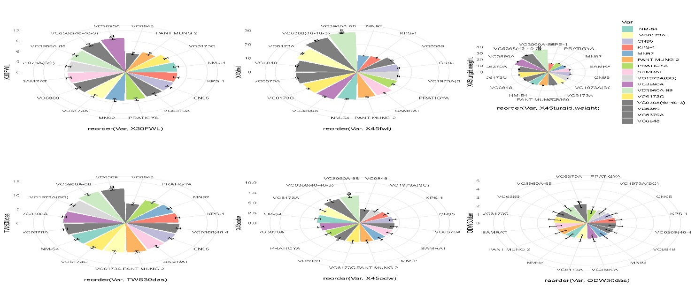

Figure 4 Comparative Analysis of Leaf Weight Dynamics — Fresh Leaf Weight (FLW), Turgid Leaf Weight (TLW), and Oven Dry Weight (ODW) — across 16 Mung-bean Genotypes at 30 and 45 DAS.

These findings suggest that genotype VC6370A is better at maintaining water content under drought stress conditions, while genotype VC6368(46-40-3) is more efficient in absorbing water. Genotype VC6370A's superior WRC could be attributed to its well-developed root system and efficient water transport mechanisms. Genotype VC6368(46-40-3)'s high WUC might be due to its larger leaf surface area, which allows for greater water absorption through transpiration *Figure 5*.

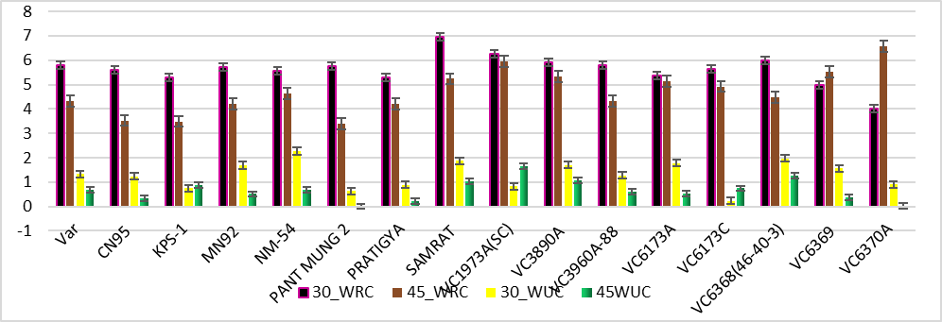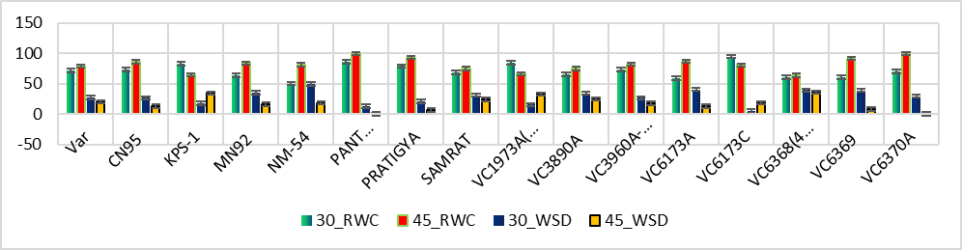

Figure 5 Comparative Analysis of Water Dynamics — Relative Water Content (RWC), Water Saturation Deficiency (WSD), and Water Uptake Capacity — among 16 Mungbean Genotypes at 30 and 45 DAS

**3.3. Correlation between Mung Bean Seedling Traits and Growing Conditions: A Rainout vs. Field Comparison**

A correlation study of mung bean seedling traits under rainout and field conditions was conducted to investigate the relationships between seedling growth and growing conditions. The study found that field secondary roots were strongly correlated with field root-to-shoot ratio (r = 0.29, p < 0.001) and field root length (r = 0.37, p < 0.001). This suggests that field secondary roots play an important role in mung bean seedling growth and development under field conditions. Additionally, field root-to-shoot ratio was strongly positively correlated with field root length (r = 0.85, p < 0.001), whereas field shoot length was negatively correlated with field root-to-shoot ratio (r = -0.50, p < 0.001). This suggests that mung bean seedlings allocate more resources to root growth under field conditions, which may be an adaptation to the more stressful growing conditions in the field.

In the rainout conditions, SPAD value was negatively correlated with shoot length (r = -0.14, p < 0.05). This suggests that rainout seedlings may be allocating more resources to chlorophyll production, rather than shoot growth, in order to maximize photosynthetic activity under the more favorable growing conditions in the rainout. Additionally, rainout root length was strongly correlated with rainout root-to-shoot ratio (r = 0.68, p < 0.001) *Figure 6*. This suggests that rainout seedlings are also allocating more resources to root growth, but to a lesser extent than field seedlings. This may be due to the more favorable growing conditions in the rainout.

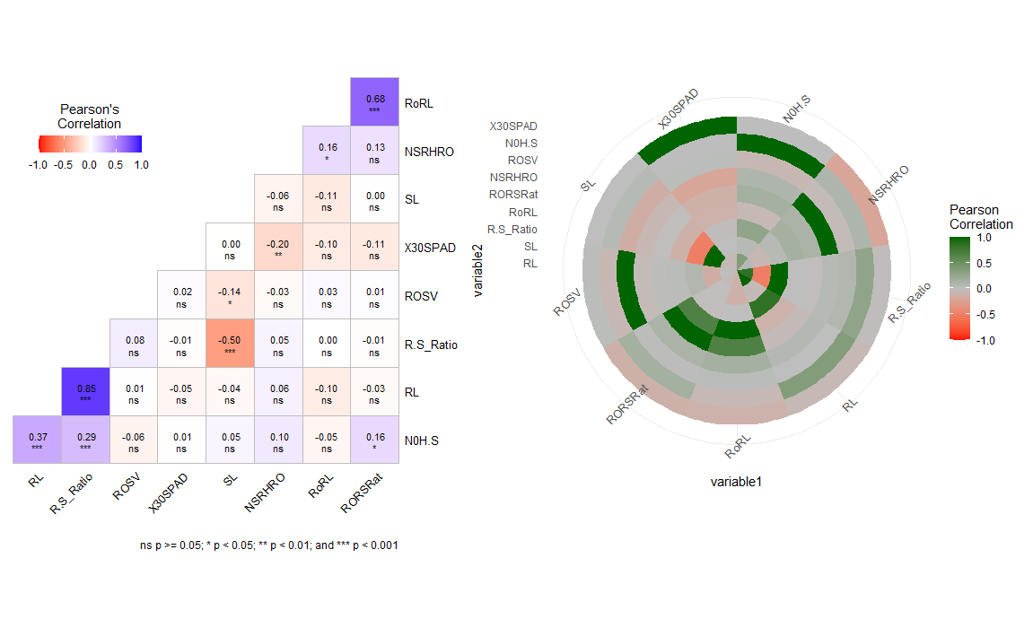

Figure 6 Correlation Relationships between Mung Bean Seedling Traits and Growing Conditions: A Heat-map Visualization

Mung bean seedlings exhibit significant genotypic variation in root and shoot architecture under both glasshouse (rainout) and field conditions. Under Heat and drought stress conditions, seedlings have longer shot and larger root-to-shoot ratios than under normal conditions. Genotype KPS1 showed the least deviation in shoot length and root length under stress conditions, indicating that it is the most resistant to stress. Genotype VC6368(46-40-3) had the longest root length under both stress and normal conditions, indicating that it is the most tolerant to heat and drought stress. Genotype CN95 showed the least deviation in root length and shoot length under stress conditions, indicating that it is a more resistant line that does not respond to temperature stress. Genotype VC3960A-88 showed the least deviation in root-to-shoot ratio under both conditions, indicating that it is a more resistant line *Table 3*.

Table 3 Source of variation sowing comparative Assessment of Seedling Traits Between Field and Stress Conditions

|  |  |  |  |  |  |  |
| --- | --- | --- | --- | --- | --- | --- |
| Genotype | RoRL± SD | RLF10 DAS± SD | RSL± SD | SL10 DAS ± SD | RtSrRo± SD | FRtSr± SD |
| VC6368(46-40-3) | 14.31±1.84 | 6.10**a**± 0.34 | 24.87±2.52 | 5.70±0.84 | 0.59±0.01 | 1.11**a**±0.03 |
| NM-54 | 11.53±1.04 | 5.34ab±0.82 | 23.13±1.88 | 5.53±0.91 | 0.52±0.01 | 1.00**ab**±0.04 |
| VC6370A | 13.13±1.19 | 5.30ab±0.95 | 24.73±2.39 | 5.30±0.70 | 0.54±0.01 | 1.02**ab**±0.02 |
| VC1973A (SC) | 10.40±1.12 | 5.24**ab**±0.30 | 24.96±1.56 | 5.60±0.19 | 0.42±0.08 | 0.98**ab**±0.03 |
| VC6173C | 16.53±2.06 | 5.13 ±0.73 | 25.20±1.62 | 5.55±0.11 | 0.65±0.06 | 0.98±0.04 |
| CN95 | 7.86j ±1.18 | 5.06±0.25 | 21.40±1.77 | 6.18ab±0.50 | 0.41±0.016 | 0.83±0.02 |
| VC6848 | 14.20±1.69 | 5.006±0.50 | 23.02±1.99 | 6.53**a**±0.69 | 0.63±0.04 | 0.81±0.03 |
| PRATIGYA | 15.20±1.42 | 4.98±0.12 | 24.84±2.40 | 6.10abc±0.35 | 0.63±0.01 | 0.86±0.02 |
| KPS-1 | 18.62±1.15 | 4.72±0.51 | 13.66±1.65 | 5.89±0.14 | 1.47**a**±0.047 | 0.80±0.03 |
| VC3890A | 16.26±2.12 | 4.68±0.21 | 24.49±1.81 | 5.34±0.84 | 0.67±0.01 | 0.89±0.02 |
| VC6173A | 13.42±1.08 | 4.49±0.84 | 25.20**ab**±1.81 | 5.43±0.56 | 0.52±0.06 | 0.82±0.01 |
| SAMRAT | 13.00±1.35 | 4.47±0.89 | 24.13±1.54 | 5.24±0.88 | 0.54±0.01 | 0.88±0.04 |
| PANT MUNG 2 | 10.60± 0.98 | 4.46±0.71 | 20.30±2.33 | 5.96±0.39 | 0.57±0.02 | 0.76±0.03 |
| MN92 | 8.66±1.91 | 4.30±0.30 | 22.93±1.82 | 6.08±0.54 | 0.38±0.08 | 0.71±0.02 |
| VC6369 | 20.46**ab**±2.16 | 4.29±0.82 | 25.31±1.63 | 5.33±0.77 | 0.80±0.02 | 0.81±0.03 |
| VC3960A-88 | 22.06**a**±1.99 | 3.98c±0.16 | 26.6**a**±1.82 | 5.56±0.18 | 0.84**b**±0.02 | 0.76±0.03 |
| LSD(0.05) | 0.36 | 0.17 | 0.51 | 0.13± | 0.025± | 0.03 |
| SEm | 0.30 | 0.09 | 0.31 | 0.06± | 0.02± | 0.02 |
| F-prob | <0.001 | <0.01 | <0.001 | <0.05 | <0.001 | <0.01 |
| CV% | 8.51 | 12.78 | 17.33 | 10.48 | 6.87 | 5.31 |
| RORL: Rainout Root Length; RLF10DAS: Root length of the field 10 days after sowing; RSL: Rainout Shoot Length; SL10DAS: Shoot length of the Field 10 DAS after sowing; RtSrRo: Root to shoot ratio of Rain out; FRtSr: Field root to shoot ratio; SD:Standard Deviation; CV: Coefficient of Variation; SEm: Standard Error of mean; F-prob: F value; LSD: least significance difference Value. | | | | | | |

This study also observed that genotype VC6848 had a higher SPAD value under both normal and stress conditions, indicating that it is more photosynthetically efficient. Heat and Drought stress can cause plant roots to change their structure and function to better adapt to the dry conditions. This can include growing more fibrous roots, which are thinner and more efficient at absorbing water, and decreasing the diameter and biomass of lateral roots, which can help to reduce water loss. Genotypes VC6368(46-40-3) and CN95 showed more secondary roots than other genotypes, indicating that they are more tolerant to temperature and heat stress *Table 4*.

Table 4 Comparison of SPAD Values and Secondary Root Development in Mung Bean Seedlings under Field and Rainout Condition

|  |  |  |  |  |
| --- | --- | --- | --- | --- |
| Genotype | Rainout SPAD Val | 30DAS SPAD value | FSr ± SD | RoSr ± SD |
| VC6368(46-40-3) | 36.35± 2.61 | 42.58±3.27 | 10.25±1.28 | 13.37a±0.44 |
| NM-54 | 32.72±1.50 | **46.32± 3.83** | 9.20±1.42 | 10.66±0.99 |
| VC6370A | 35.48±2.85 | 44.20 ± 2.24 | 11.00 ±1.20 | 11.93±1.05 |
| VC1973A(SC) | 37.40**a**±1.99 | 43.70 ± 3.39 | 7.93±1.90 | 10.06±0.43 |
| VC6173C | 34.82±1.70 | 44.58±3.34 | 8.46±1.64 | 9.53±0.88 |
| CN95 | 35.14±2.57 | 44.46±3.44 | 11.40ab±1.83 | 7.66±0.17 |
| **VC6848** | **37.22a±1.20** | **45.58±2.77** | 8.80±1.73 | 7.333±0.771 |
| PRATIGYA | 31.73**c**±1.32 | 43.49±3.18 | 7.93±1.71 | 10.00±0.68 |
| KPS-1 | 34.92±2.34 | 41.75±3.63 | **13.30a±2.69** | 12.86±0.99 |
| VC3890A | 37.73a±2.43 | 42.52±2.81 | 10.00±1.43 | 9.40± 0.59 |
| VC6173A | 35.01±1.03 | 42.83±3.43 | **7.57±1.55** | **13.57a±0.15** |
| SAMRAT | 36.86**a**±2.81 | 42.97±2.49 | 8.20±1.68 | 11.33±0.67 |
| PANT MUNG 2 | 35.26±2.80 | **47.61a ±3.44** | 8.13±1.45 | 4.93±1.05 |
| MN92 | 34.53±1.33 | 45.18±3.81 | 8.733±1.17 | 9.066±0.05 |
| VC6369 | 35.84±2.25 | 41.24±2.47 | 7.40±1.35 | 8.40±0.47 |
| VC3960A-88 | 36.22**ab**±1.10 | 41.22±3.90 | 7.13e±1.19 | 10.80±1.05 |
| LSD(0.05) | 0.31 | 0.805 | 0.43 | 0.31 |
| SEm | 1.06 | 0.411 | 0.24 | 0.21 |
| F-prob | <0.01 | <0.05 | <0.001 | <0.001 |
| CV% | 6.08 | 8.4600 | 18.62 | 9.12 |
| Grand Mean | 23.46 | 43.77042 | 9.10 | 10.05 |
| Rainout SPAD val: Glass house Seedling SPAD value; 30 das SPAD Value: 30 Days after sowing SPAD value; FSr: Field Secondary Roots/plant; RoSr: Rainout Secondary Roots/plant; SD:Standard Deviation; CV: Coefficient of Variation; SEm: Standard Error of mean; F-prob: F value; LSD: least significance difference Value. | | | | |

**3.4. Pre-****Fertilization Phenotypic Traits Evaluation of Different Genotypes Under Field Conditions: An Analysis of Variance and Mean Comparison Approach**

Plant height was significantly different (P < 0.001) among the genotypes at both 30 and 45 days after sowing (DAS). Genotype CN95 had the tallest plants at both 30 DAS (7.70 cm) and 45 DAS (16.64 cm), followed by genotypes VC6370A and VC1973A(SC). The number of trifoliate leaves was not significantly different (P > 0.05) among the genotypes at 30 DAS. However, at 45 DAS, genotype NM54 had the highest number of trifoliate leaves (7.33), followed by genotype VC3960A-88 (7.13). The number of root nodules at 30 and 45 DAS was significantly different (P < 0.001) among the genotypes. Genotypes NM54 (12.26) and VC6370A (12.64) had the highest number of root nodules at both 30 and 45 DAS, respectively. Genotype VC6173C had the lowest number of root nodules at 45 DAS (7). Genotypes CN95, MN92, NM54, Pant Mung 2, and all VC series genotypes had statistically similar numbers of root nodules. The diameter of the root nodules was also significantly different (P < 0.001) among the genotypes at 45 DAS. Genotype CN95 had the largest diameter of nodules (2.30 mm), followed by genotypes Pant Mung 2 and NM54. Genotypes VC6173A and VC3890A had the smallest diameter of nodules (1.74 mm). The effective number of root nodules was significantly different (P < 0.001) among the genotypes at 45 DAS. Genotype VC6370A had the highest effective number of root nodules (10.20). The SPAD value was significantly different (P < 0.001) among the genotypes at 45 DAS. Genotype VC3960A-88 had the highest SPAD value (66.13), followed by the other genotypes. There was significant variation in agronomical and morphological parameters among the mung bean genotypes. Genotypes CN95, NM54, and VC6370A performed well for most of the parameters studied *Figure 9*-*Figure 8*-*Figure 7*. Further research is needed to validate these findings under different environmental conditions.

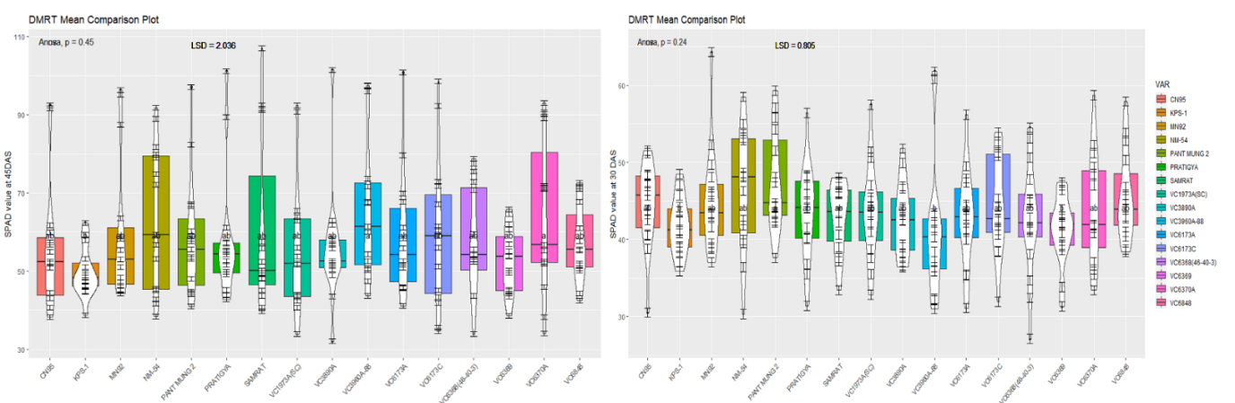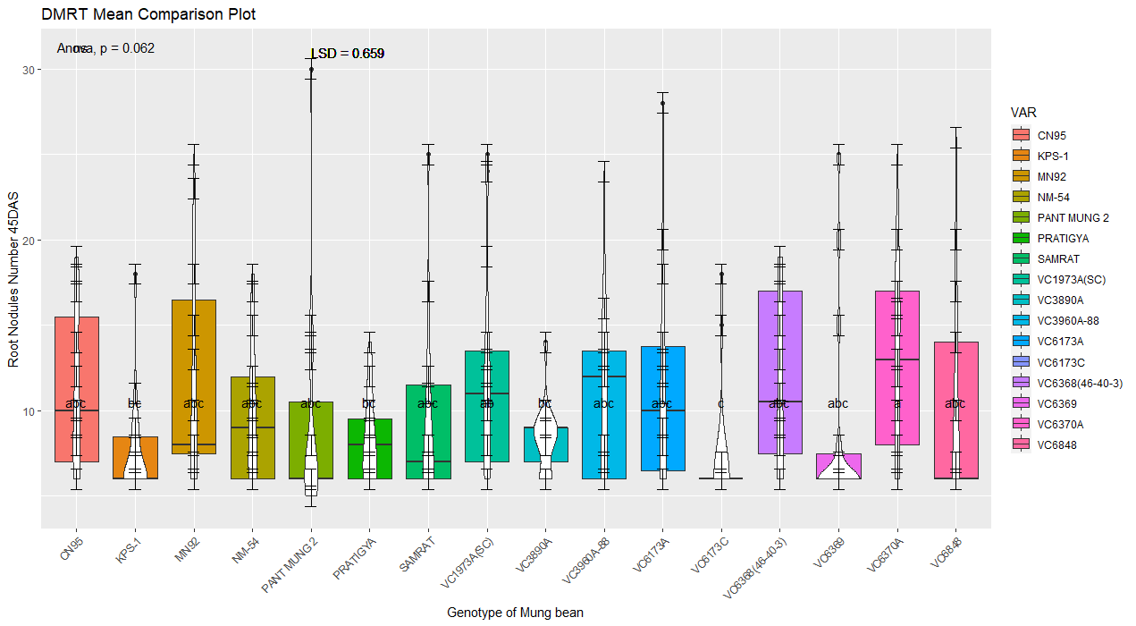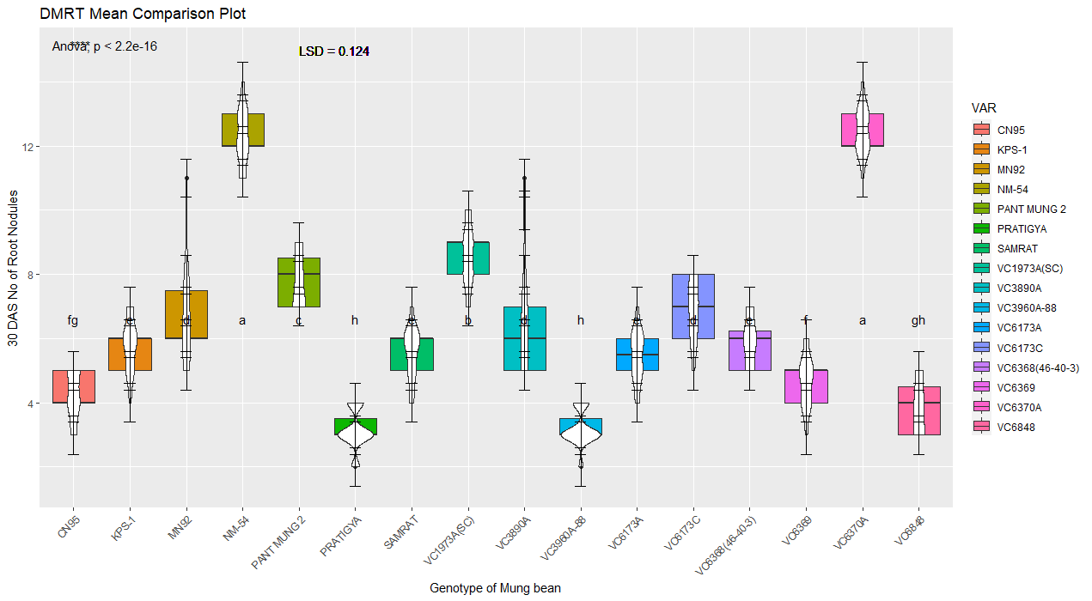

A

B

C

D

Figure 7 SPAD value(B&A) and number of root nodules(D&C) at 30 and 45 DAS among the mung bean genotypes. Box and Violin plot represent the mean values, and error bars represent the standard error of the mean. Different letters indicate significant differences between the genotypes (P < 0.01, 0.001, 0.05).

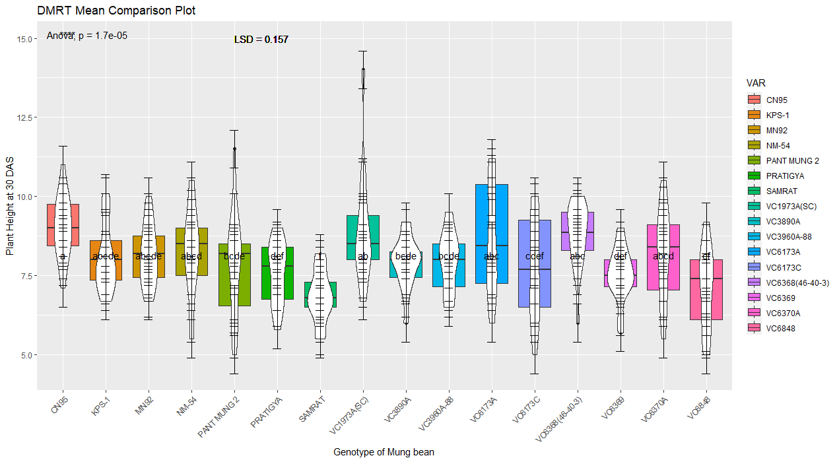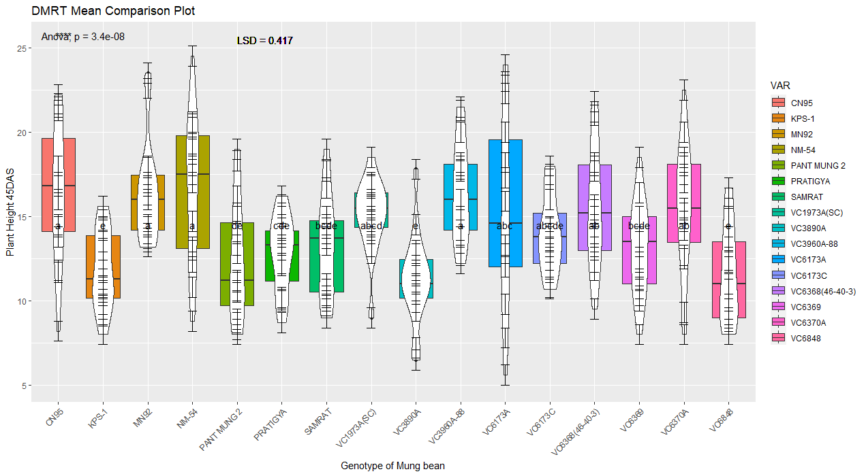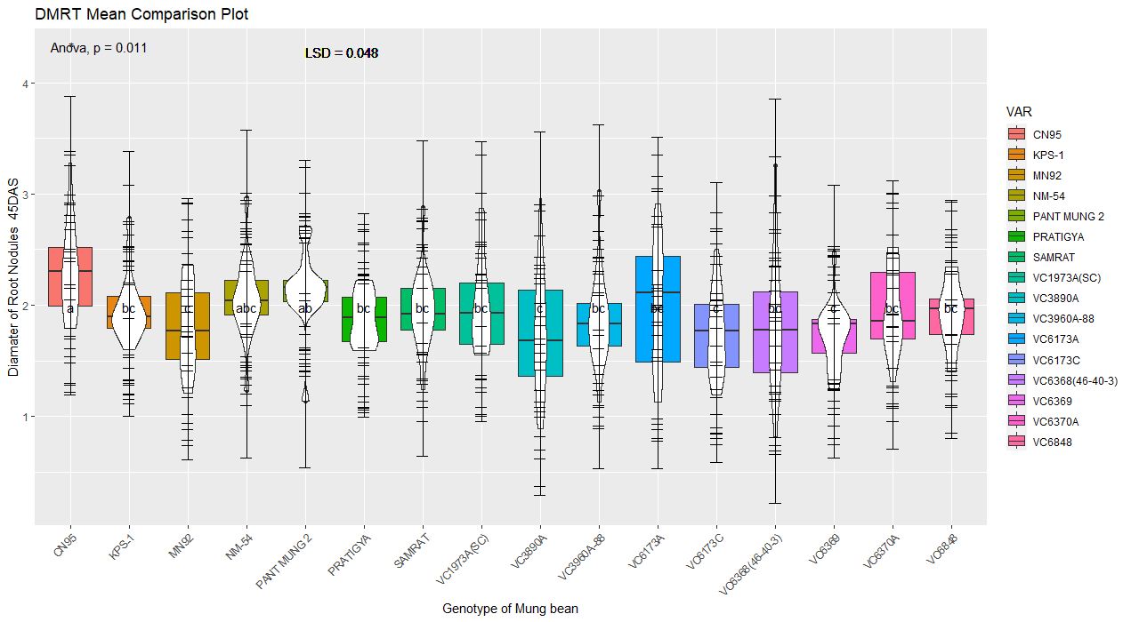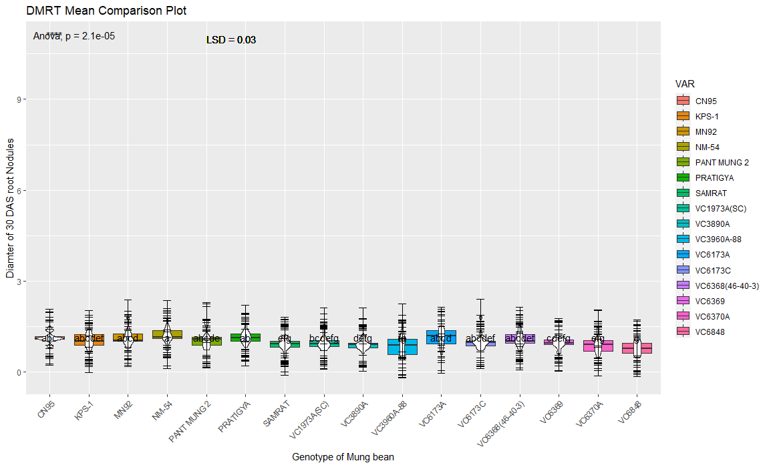

H

G

E

F

Figure 8 Plant Height (E&F) and Diameter of root nodules(G&H) at 30 and 45 DAS among the mung bean genotypes. Box and Violin plot represent the mean values, and error bars represent the standard error of the mean. Different letters indicate significant differences between the genotypes (P < 0.01, 0.001, 0.05).

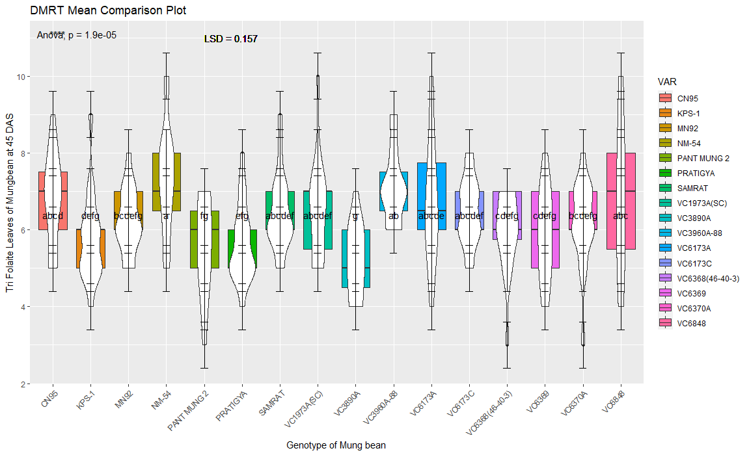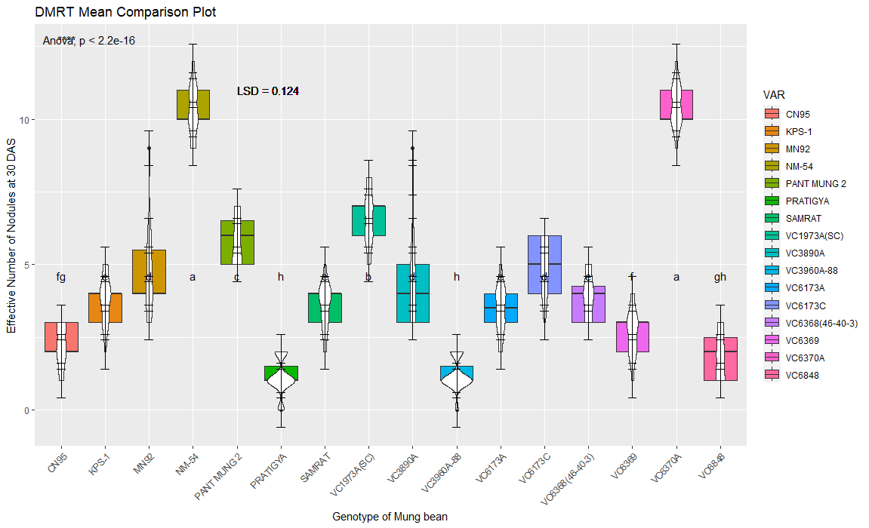

J

I

Figure 9 Trifoliate leaves 30DAS(I) and effective number of nodules 45 DAS(J) among the mung bean genotypes. Box and Violin plot represent the mean values, and error bars represent the standard error of the mean. Different letters indicate significant differences between the genotypes (P < 0.01, 0.001, 0.05).

**3.5. Post flowering Yield associated Traits Evaluation of Different Genotypes through Analysis of Variance and Mean Comparison.**

Duncan's multiple range test revealed significant differences (P<0.001, P<0.01, and P<0.05) in yield and associated attributes among the mung bean genotypes. CN95 had the longest pods (9.20 cm), followed closely by VC3960A-88 (9.04 cm). VC6368(46-40-3) had the highest number of clusters per pod (10.5), followed by VC3960A-88 (7). MN92 had the highest number of clusters per plant, followed by CN95. VC1973A(SC) had the largest seed diameter (4.06 mm), and CN95 had the highest number of seeds per pod (10), followed by VC6370A (8).CN95 has the highest seed count per pod (10 seeds), while MN95 has the highest number of clusters per plant but the fewest seeds per pod (7). The remarkably low p-values (F-prob <0.001) for all measured traits indicate that there are statistically significant differences among the genotypes for all of these characteristics. This highlights the importance of genotype selection in mung bean breeding programs *Table 5*.

Table 5 Evaluation of Mung Bean Genotypes for Pod and Seed related phenotypes

|  |  |  |  |  |  |
| --- | --- | --- | --- | --- | --- |
| Genotypes | Length of the Pod ± SD | No of Pod/Cluster ±SD | Number of cluster/Plant± SD | Diameter of Seed ± SD | Number of Seed/Pod ± SD |
| VC6368(46-40-3) | 8.62 ± 1.09 | **10.5a** ± 0.71 | 7.31±0.092 | 3.60 ± 0.44 | 8.68± 0.24 |
| **NM-54** | 8.75 ± 0.97 | 4.93 ± 0.37 | 6.60±0.32 | 3.64 ± 0.16 | 6.20±0.74 |
| VC6370A | 8.14 ±1.33 | 6.66± 0.98 | 8.00±0.92 | 3.92 ± 0.25 | **8.96**± 0.94 |
| VC1973A(SC) | 7.99 ± 0.64 | 7.60**b**± 0.64 | 9.00±0.58 | **4.06** ± 0.41 | 7.93 ± 0.25 |
| VC6173C | 6.98± 1.42 | 6.71± 0.55 | 5.60±0.50 | 3.75 ± 0.39 | 8.20± 0.95 |
| CN95 | **9.20a** ± 0.81 | 7.00 ± 0.34 | **8.20**±0.8 | 3.62± 0.33 | **10.46**± 0.16 |
| VC6848 | 8.16 ± 1.36 | 5.46 ±0.55 | 6.80±0.1 | 3.86 ± 0.15 | 8.53±0.58 |
| PRATIGYA | 9.02±0.84 | 5.73 ± 0.45 | 7.00±0.4 | 3.53 ±0.23 | 8.93± 0.21 |
| KPS-1 | 7.45 ± 0.90 | 2.8 ±0.73 | 4.13±0.47 | 3.87± 0.40 | 5.13± 0.81 |
| VC3890A | 8.34 ±0.93 | 4.20 ± 0.11 | 5.60±0.22 | 3.71± 0.29 | 8.66± 0.28 |
| VC6173A | 8.02 ± 0.88 | 6.71 ± 0.55 | 9.21±0.77 | 3.75± 0.28 | 7.42± 0.60 |
| SAMRAT | 7.43 ± 1.19 | 3.60 ± 0.45 | 4.80±0.89 | 3.67± 0.32 | 8.00± 0.53 |
| PANT MUNG 2 | 8.16 ± 0.75 | 4.20 ± 0.16 | 5.86±0.50 | 3.59 ±0.28 | 7.66±0.26 |
| MN92 | 8.84 ± 0.67 | 5.26 ± 0.90 | **9.20**±1.00 | 3.73 ±0.18 | 4.40±0.01 |
| VC6369 | 8.35 ± 1.46 | 5.80± 0.24 | 7.00±0.6 | 3.79 ±0.28 | 6.40±0.88 |
| VC3960A-88 | **9.04b** ±1.146 | 7.80**b**± 0.93 | 7.40±1.18 | 3.96 ± 0.17 | **8.60**±1.20 |
| LSD-(0.05) | 0.135 | 0.675 | 0.39 | 0.03 | 0.35 |
| SEm | 0.074 | 0.353 | 1.03 | 0.02 | 0.20 |
| F-prob | <0.001 | <0.05 | <0.001 | <0.001 | <0.001 |
| CV% | 12.63 | 9.82 | 5.396 | 8.162 | 8.82 |

Several mung bean genotypes display promising traits for crop breeding and agricultural improvement. VC6370A and VC3960A-88 have high 100-grain seed weights, which could increase both grain yield and nutritional quality. VC6368(46-40-3) and VC1973A(SC) produce high straw yields, making them valuable for livestock feed and soil enrichment. VC6370A has the highest grain yield (3.04 ton/ha), followed by CN95 (2.84 ton/ha). This suggests that VC6370A has the potential to boost agricultural productivity and food security. VC3960A-88 has an efficient harvesting index, which means that it optimally uses resources to produce grain *Table 6*.

Table 6 Identification of high-yielding mung bean genotypes through evaluation of key yield-related traits

|  |  |  |  |  |  |
| --- | --- | --- | --- | --- | --- |
| Genotypes | 100 Grain seed weight± SD | Straw Yield/ha± SD | Biological Yield kg/Ha± SD | Harvesting Index± SD | Grain yield (Tons)/ha± SD |
| VC6368(46-40-3) | 5.15±0.0765 | 3197±0.00 | 5779.60±0.005 | 0.45 ±0.00 | 2.064±0.00 |
| NM-54 | 5.41±0.00 | 3154±0.00 | 5678.20 ±0.005 | 0.44 ±0.00 | 2.016±0.00 |
| VC6370A | **5.88**±0.00 | 3126±0.00 | 5610.36±0.005 | 0.44 ±0.00 | **2.432a** ±0.00 |
| VC1973A(SC) | 4.96±0.00 | **3207±**0.00 | 5920.08±0.005 | 0.46 ±0.00 | 2.168±0.00 |
| VC6173C | 5.39±0.00 | 3056±0.00 | 5035.12 ±0.005 | 0.41 ±0.00 | 1.668±0.00 |
| CN95 | 5.26±0.00 | 3293±0.00 | 6133.08 ±0.005 | **0.48 a** ±0.00 | **2.272ab** ±0.00 |
| VC6848 | 5.80±0.00 | 3013±0.00 | 5385.60 ±0.006 | 0.44 ±0.00 | 1.896±0.00 |
| PRATIGYA | 5.46±0.00 | 3012±0.00 | 5322.534±0.005 | 0.43 ±0.00 | 1.848±0.00 |
| KPS-1 | 6.66±0.00 | 2360±0.00 | 3494.18 ±0.005 | 0.32 ±0.00 | 0.9072±0.00 |
| VC3890A | 6.21±0.00 | 3120±0.00 | 5578.330±0.005 | 0.44 ±0.00 | 1.96±0.00 |
| VC6173A | 4.87±0.00 | 3056±0.00 | 5545.172±0.005 | 0.45 ±0.00 | 1.984±0.00 |
| SAMRAT | 5.40±0.00 | 2120±0.00 | 3378.120±0.005 | 0.37 ±0.00 | 1±0.00 |
| PANT MUNG 2 | 4.75±0.00 | 2930±0.00 | 5178.700±0.005 | 0.43 ±0.00 | 1.792±0.00 |
| MN92 | 4.85±0.00 | 3186±0.00 | 5684.88 ±0.005 | 0.44±0.00 | 1.992±0.00 |
| VC6369 | 5.36±0.00 | 2993±0.00 | 5805.60 ±0.005 | **0.46b**±0.00 | 2.248±0.00 |
| VC3960A-88 | 5.07±0.00 | 3267±0.00 | **6316.657** ± 1729.933 | 0.46**b** ±0.00 | **2.264ab**±0.072 |
| LSD(0.05) | 0.002 | 1.24 | 54.97426 | 0.0024 | 0.054 |
| SEm | 0.032 | 19.97 | 111.58 | 0.003 | 0.042 |
| F-prob | <0.001 | <0.001 | <0.001 | <0.001 | <0.001 |
| CV% | 0.36 | 0.32 | 8.05 | 4.47 | 3.06 |

**3.6. Correlation among the Vegetative and Reproductive traits of the Mung bean genotype.**

The correlation matrix in (**supplementary table**) and *Figure 10* shows the pairwise relationships between variables, computed using Pearson's correlation with list wise deletion for missing data. Each cell contains a correlation coefficient, which quantifies the strength and direction of the linear relationship between two variables, assessed for statistical significance at the 0.05 or 0.001 level. Several notable correlations were observed. A correlation study of tri-foliate mungbean traits was conducted to investigate the relationships between plant growth and yield. The study found that plant height at 30 and 45 days after sowing (DAS) was strongly positively correlated with straw yield per hectare (SY.Ha), biological yield per hectare (B.Ha), and harvesting index (HI) (p < 0.001, r = 0.26 to 0.34). This suggests that taller plants tend to have higher yields. Trifoliate leaf number at 30 and 45 DAS was also significantly positively correlated with plant height, biological yield, and harvesting index (p < 0.05, r = 0.13 to 0.15). This suggests that plants with more trifoliate leaves tend to have higher yields. In addition, the study found that effective number of root nodules at 30 and 45 DAS was significantly positively correlated with the diameter of nodules (p < 0.001, r = 1.00). This suggests that plants with more effective root nodules tend to have larger nodules. This is likely because effective root nodules are able to fix more nitrogen from the air, which can lead to increased plant growth and yield. The study also found that number of grains per pod was positively correlated with grain yield per hectare (r = 0.67, p < 0.05). This suggests that plants with more grains per pod tend to have higher grain yields. However, 100-grain weight was negatively correlated with straw yield per hectare (r = -0.80, p < 0.001) and biological yield per hectare (r = -0.63, p < 0.05). This suggests that plants with heavier grains tend to have lower straw and biological yields. This is likely because plants with heavier grains allocate more resources to grain production and less resources to straw and root production. Grain yield/ha is strongly correlated with clusters/plant(p<0.001, r=0.54) harvesting index(p<0.001, r=0.99) and Biological yield(p<0.001, r=0.99).

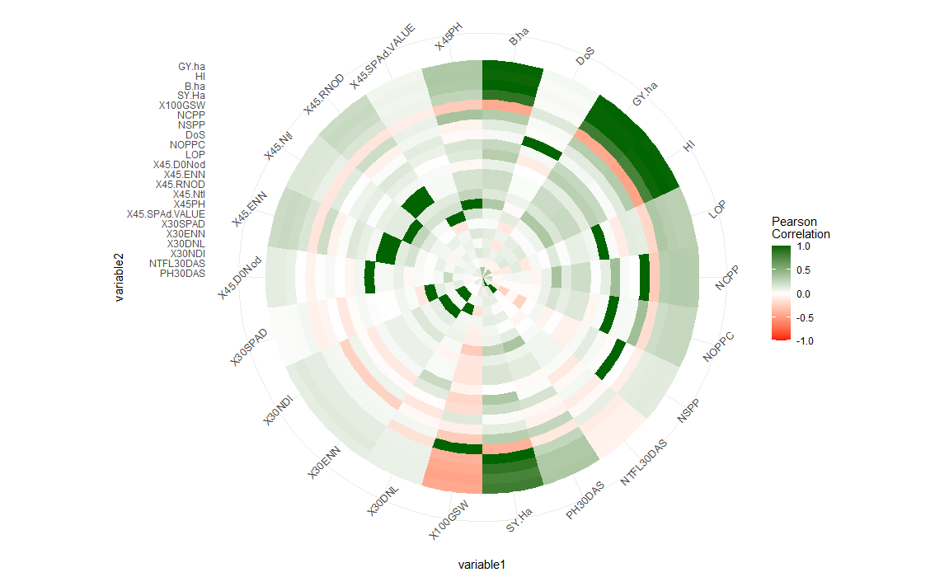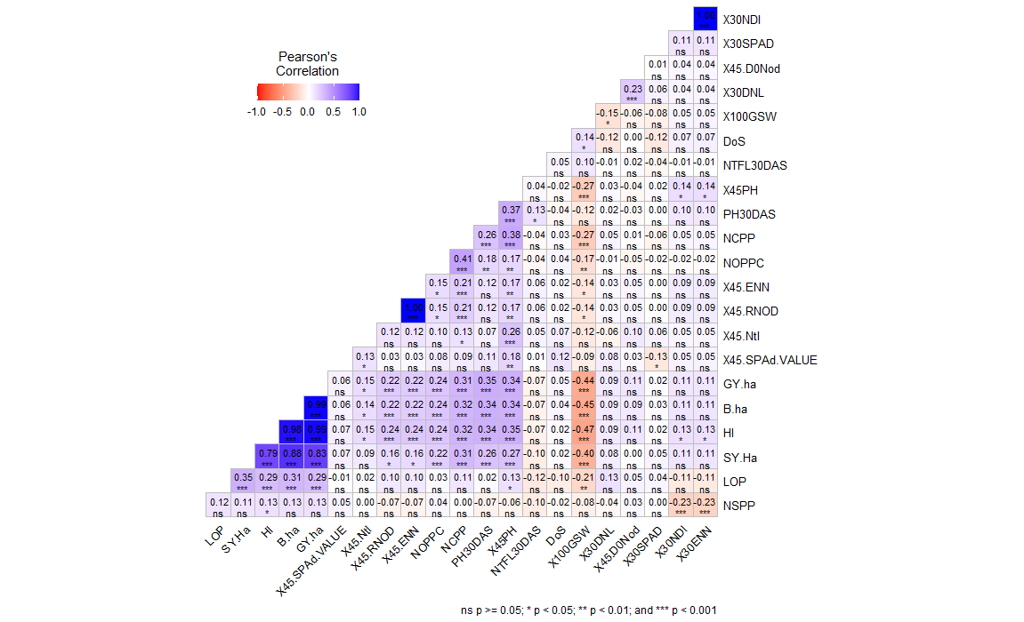

Figure 10 Correlation Heatmap depicting relationships among agronomic and morphological traits under field condition

**3.7. Multivariate Analysis of Agro-morphological and Reproductive Traits among Genotypes Using Principal Component Analysis, PCA Biplot, Cluster Analysis and Multi Traits Stability Index analysis.**

3.7.1. PCA analysis:

Singular Value Decomposition (SVD) and Principal Component Analysis (PCA) are closely related concepts in the field Plant traits contribute to yield in a variety of ways. A recent study identified nine traits that contributed significantly to grain yield in dimension one: 45-day plant length (X45PH), number of clusters per plant (NCCP), 100-grain weight (X100GSW), grain yield per hectare (GY.ha), harvesting index (HI), plot yield, sample plant yield (Y.PSP), straw yield per hectare (SY.Ha), and biological yield per hectare (B.ha). The highest contribution factor for dimension one was B.ha. Dimension two had six traits that contributed to yield: white portion below ground (BGWP), diameter of seed (DoS), seed number per pod (NSPP), 45 DAS effective number of nodules (X45.ENN), length of seed (LOS), area of seed (AOS), 30 DAS nodules, and effective number of nodules Figure 11. The highest contribution factor for dimension two was X45.ENN. Dimensions three and four also had six principle contribution variables that exhibited the threshold. Dimension three had a unique variable, root length (RL), with all other principle contribution variables also accounted for in dimension two. All principle contribution variables for dimension four were accounted for in principal components 1 and 2, respectively.

Figure 11 displays the percentage contributions of variables to the principal components (PCs) using distinct colors for each PC. The bars corresponding to PC1 are represented in brown, PC2 in light green, PC3 in dark green, and PC4 in blue. red dashed reference lines are overlaid across the bar plots. Variables with bars extending above these reference lines are considered significant contributors to their respective PCs.

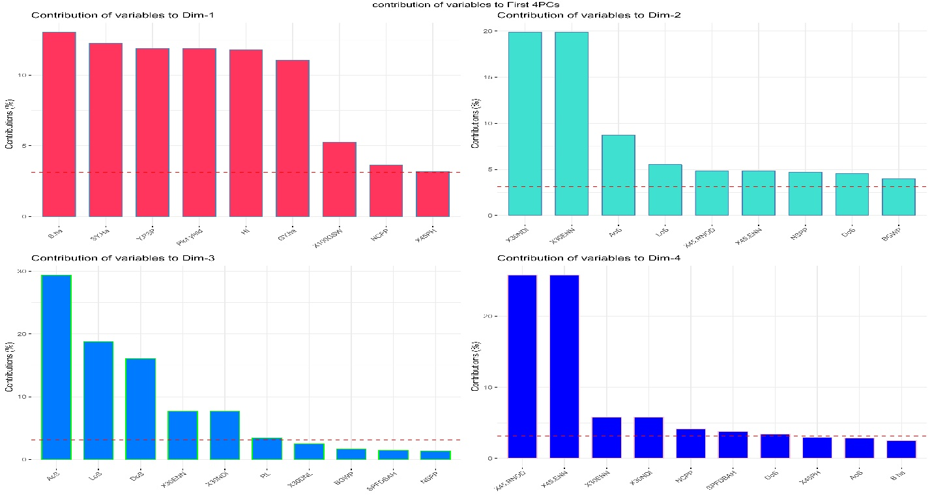

PCA scatter plot shows how the different genotypes traits are distributed in two-dimensional space, based on their values for the first two PCs. The PCA loading plot shows how the different traits are correlated with the first two PCs. The correlation circle shows the magnitude and direction of the correlations between the traits and the first two PCs. The first two principal components (PCs) of a PCA analysis of mung bean genotypes were able to correctly separate all genotypes into four quadrants (*Figure 12*). This indicates that the genotypes are well-distributed along both axes and represent a wide range of phenotypic variability. The PCA analysis of quantitative data showed that the first two PCs accounted for most of the variance (*Figure 12*). A correlation circle can be used to visualize the contribution of individual traits to sample differentiation, with vectors representing the quantitative variables, normalized to unit length.

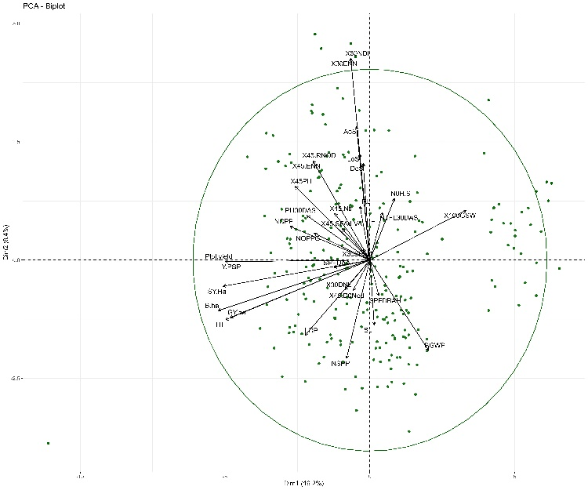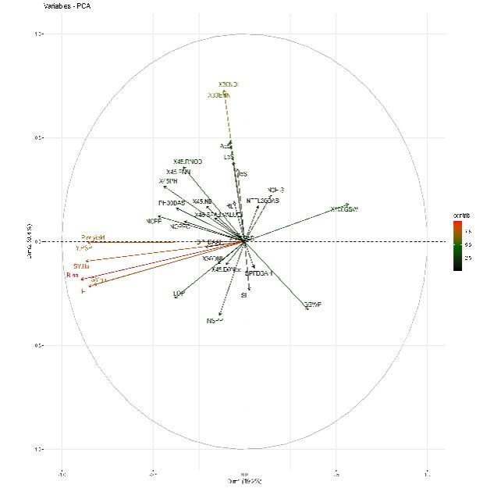

Figure 12 Representation of PCA Scatter Plots for Genotype Traits(A) Relationships and Variable Distribution in Mung Bean Analysis(B). RL=Root Length, SL=Shoot Length, R.S Ratio=Root to Shoot Ratio,N0H.S=Number of Secondary Roots, BGWP= Below ground White Portion,PH30DAS and X45PH= Plant Height 30 and Days after sowing, NTFL30DAS& X45.Ntl =Number of Tri-foliates leaves 30 and 45 DAS ,X30NDl & X30DNL=Number and Diameter of 30 days nodules, X30ENN & X45.ENN =effective number of root nodules 30 AND 45DAS,X30SPAD & X45.SPAd.VALUE=30 and 45DAS SPAD value,X45.RNOD= Root Nodules 45DAS,X45.D0Nod=45 Days Diameter of Nodules, LOP=Length of the Pod, NOPPC=Number of Pod Per Cluster, DoS & AoS=Diameter and Area of seed, NSPP=Number of seed/Pod, NCPP=Number of Cluster Per plant,X100GSW=100 Grain weight, SY.Ha= straw yield/ha, B.ha=Biological yield/ha, HI=Harvestig Index, GY.ha =Grain Yield/ha are used as experimental variables, respectively

A

B

I

III

II

IV

In Principal Component 1 (PC1), several traits, including BGWP (white portion below ground), X100GSW (100-grain weight), NTFL30DAS (number of total flower buds at 30 days after sowing), NOH.S (secondary roots numbers), and SAFDBA (Flower drops at 50% flowering), had positive contributions to the variance(quadrant I & IV). The remaining traits had negative contributions. In PC2, positive contributions were observed from traits such as NCCP (clusters per plant), NOPPC (pods per cluster), X45SPAD Value (SPAD value at 45 days after sowing), X45.Ntl (nodules at 45 days after sowing), X45.RNOD (root nodules diameter at 45 days after sowing), X30ENN (effective nodule number at 30 days after sowing), X30NDL (nodule length at 30 days after sowing), DoS (diameter of seed), AoS (area of seed), and X30SPAD (SPAD value at 30 days after sowing). Conversely, GY.ha (grain yield per hectare), B.ha (biological yield per hectare), SY.ha (straw yield per hectare), HI (harvesting index), LOP (length of pod), NSPP (number of seeds per pod), X30DNL (nodule diameter at 30 days after sowing), X45DoNod (root nodules at 45 days after sowing), and SPFDAAH (sample plant flower drops at 50%flowering) traits displayed negative contributions in both PC1 and PC2(quadrant III). The magnitude and direction of PCA vectors are indicative of the importance of each variable. Variables that are closely aligned (small angle) are positively correlated, while variables that are oppositely aligned (180-degree angle) are negatively correlated. Variables that are orthogonal (90-degree angle) are uncorrelated. Among the 33 variables, NOHS (number of open flowers at 50% flowering), X30DNL (nodule diameter at 30 days after sowing), X45DoNod (root nodules at 45 days after sowing), RL (root length), X45Ntl (number of total nodules at 45 days after sowing), DoS (diameter of seed), SL (seed length), and 45 SPAD values exhibited lower magnitude and shorter vector length. In contrast, HI (harvesting index), B.ha (biological yield per hectare), SY.ha (straw yield per hectare), plot yield, YPSP (yield per sample plant), X30ENN (effective nodule number at 30 days after sowing), X30NDL (nodule length at 30 days after sowing), and X100GSW (100-grain weight) demonstrated a higher magnitude of variance compared to the remaining variables. Variables represented by red arrows have a close alignment angle, indicating high correlation.

The total variance explained by the first 12 PCs is 73.00%. This means that the remaining 27.00% of the variance is explained by the remaining PCs. The first two PCs explain 19.25% and 8.39% of the variance, respectively. This means that these two PCs account for the most variation in the data. The cumulative percentage of variance for the first four PCs is 40.72%. This means that these four PCs together explain over 40% of the variation in the data. PCs with the highest eigenvalues and percentage of variance are likely to be the most important. These 12 components meet the criteria defined by Kaiser, as they possess eigenvalues greater than 1 *Table 7*.

Table 7 Visualization of Principal Components with Eigenvalues Greater Than 1, Including Percentage and Cumulative Percentage of Variance

|  |  |  |  |
| --- | --- | --- | --- |
| PCs | eigenvalue | percentage of variance | cumulative percentage of variance |
| PC1 | 6.16 | 19.25 | 19.25 |
| PC2 | 2.69 | 8.39 | 27.64 |
| PC3 | 2.23 | 6.97 | 34.61 |
| PC4 | 1.96 | 6.12 | 40.72 |
| PC5 | 1.65 | 5.17 | 45.89 |
| PC6 | 1.54 | 4.81 | 50.71 |
| PC7 | 1.37 | 4.27 | 54.98 |
| PC8 | 1.29 | 4.03 | 59.01 |
| PC9 | 1.22 | 3.81 | 62.82 |
| PC10 | 1.12 | 3.51 | 66.33 |
| PC11 | 1.12 | 3.49 | 69.82 |
| PC12 | 1.02 | 3.17 | 73.00 |

The scree plot in Figure 13 provides a visual representation of eigenvalues and their respective contributions to the total variance. The highest eigenvalue is 6.2, which is attributed to the first principal component. This component explains 19.25% of the variance, and 19.5% of the cumulative explained variance across all components. The first seven principal components collectively explain 55% of the total variance among the genotypes.

The high eigenvalue of 6.16 for the first principal component underscores its significance in capturing a substantial portion of the variation in the phenotypic parameters of the genotypes. This information can be valuable to plant breeders, enabling them to effectively identify genotypes with the most desirable phenotypic attributes, thereby facilitating the differentiation of diverse genotype populations within Mung bean genotypes.

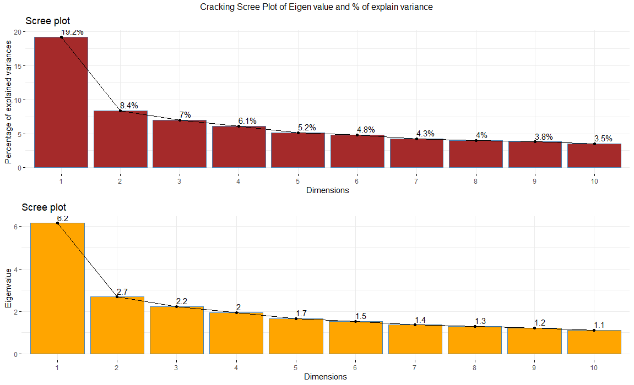

Figure 13 Scree Plot Illustrating Eigenvalues and Percentage of Explained Variance for the Top 10 Principal Components, with Labels Representing the Variance Explained in Phenotypic Diversity of Mung-bean Genotypes by Each Components

**3.7.2. Biplot Elipse of the PCA.**

The principal component analysis (PCA) biplot shows that all mung bean genotypes and promising cultivars are distributed across the four quadrants of the ellipse plot *Figure 14*. However, when their distribution is considered within these quadrants based on quantitative attributes, specific genotypes and promising cultivars tend to cluster in certain quadrants. The quantitative attribute 100-grain seed weight is more associated with the light green square legend cluster, which contains the genotypes 'Samrat' and 'KPS'. Similarly, other yield attributes such as grain yield, harvesting index, length of pod, biological yield, straw yield, and number of clusters per plant are concentrated in the plus sign legend cluster, which contains the genotypes 'CN95', 'VC6173A', and other VC accessions. The red circle legend cluster contains more promising cultivars such as Pant 'Mung 2' and 'Pratigya', which have high SPAD values, trifoliate leaves, and flower shedding. The green triangle legend cluster contains genotypes such as 'VC6368(46-40-3)', 'VC1973A', 'VC6370A', and 'VC6173C,' whose seed dimensions (area, length, and diameter), and 30 and 45 DAS root nodules diameter and effective number of nodules are distributed. By identifying the clusters in the PCA biplot that are associated with specific quantitative attributes, plant breeders can focus their breeding efforts on genotypes that are located in these clusters for that traits. The PCA biplot can be used to identify genotypes that are complementary to each other, and these genotypes can then be crossed to produce new cultivars with improved traits. Overlapped biplot traits are traits are highly correlated with each other. SPAD value, trifoliate leaves, and flower drops, which are all located in close proximity to each other in the red circle legend cluster. This suggests that these traits are also highly correlated with each other.

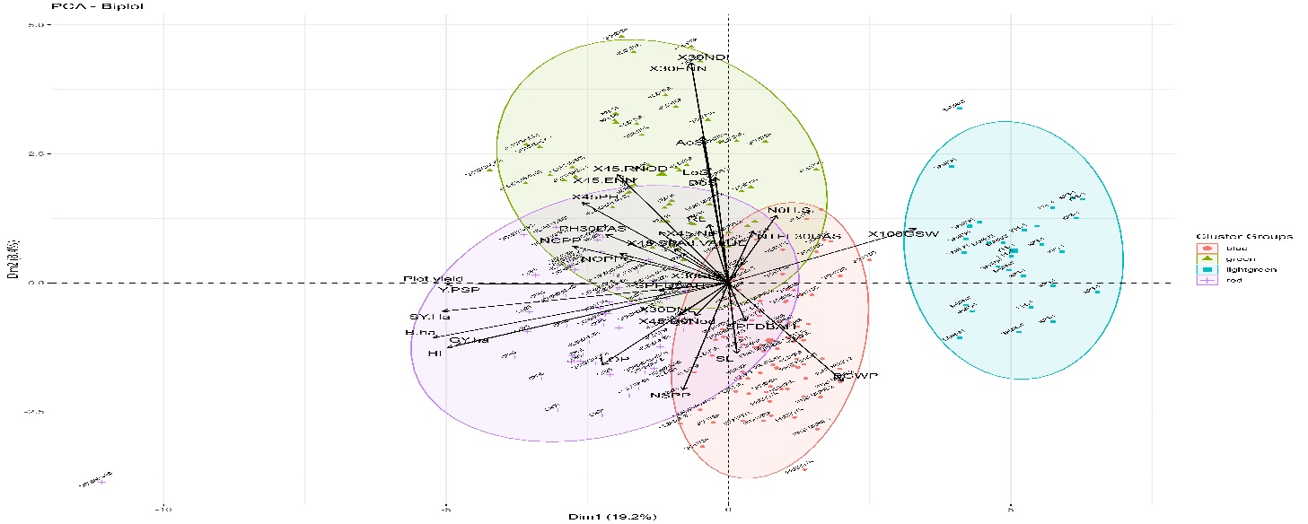

Figure 14 Graphical Representation of PCA Biplot and Ellipse Cluster Plot with Experimental Variables

3.7.3. **Hierarchical cluster analysis of the genotype.**

To determine the optimal number of clusters, the elbow technique was used, suggesting four clusters as the most effective. K-means clustering was applied to assess the diversity of 13 mung bean genotypes and 3 promising cultivars. In this analysis, pairwise dissimilarity among individuals based on 39 phenotypic descriptors, such as growth and yield-associated traits, was quantified using the Euclidean distance. The k-means clustering algorithm was then applied to group individuals into pre-specified clusters by maximizing the distance between individuals in different clusters. Four distinct clusters were identified, characterized by a dissimilarity CV of 0.172 *Figure 15*. Notably, 'VC6370A' and 'VC3960A-88' were grouped into the **I** cluster, which has the highest intra-cluster dissimilarity (440). In contrast, 'NM-54', 'VC6369', 'Samrat', 'VC6368(46-40-3) and 'VC3890-A' belongs to same **II** cluster which is second largest cluster but lowest value of intra cluster dissimilarities (164.8274). The **III** cluster also comprising three genotypes, included 'CN95' and 'Pang Mung 2,' and 'VC6848' having second highest intra cluster dissimilarities (**409.946)**. Finally, 'MN92' and whole genome sequence 'VC6163A' series genotypes belonged to the **IV** and highest cluster containing 6 genotypes. Intra and inter-cluster distances using the centroid linkage method are shown **Table 6**. The highest inter-cluster distance was observed between clusters I and II (5959.402), while the lowest inter-cluster distance was observed between clusters IV and III *Table 8*.

Table 8 Quantification of Inter and Intra-cluster Distances Based on Phenotypic Markers in Experimental Genotypes of Mung Bean

|  |  |  |  |  |
| --- | --- | --- | --- | --- |
| **Clusters** | I | II | III | IV |
| I | **440.6875** |  |  |  |
| II | 5959.402 | **164.8274** |  |  |
| III | 2102.300 | 3901.142 | **409.9461** |  |
| IV | 3798.374 | 2228.011 | 1702.288 | **229.3632** |

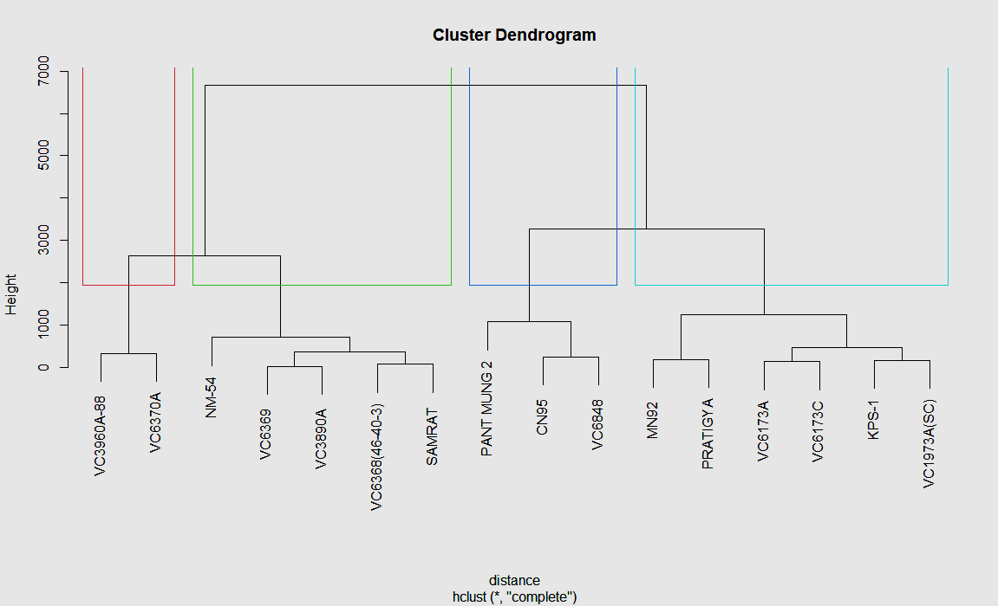

I

II

III

IV

Figure 15 Cluster Analysis: Hierarchical Clustering of Agronomic and Morphological Traits among the genotypes.

3.8. **Multi-Trait Stability Index (MTSI) Assessment among the tested genotype**

Three genotypes VC6848 , VC1973A and CN95, have been identified as the optimal genetic strains for mung-bean cultivation in Chitwan, based on a comprehensive analysis of key attributes highlighted in *Figure 11*. These genotypes are considered top-notch in terms of both stability, adaptability and overall performance among the varieties investigated. Genotype CN95 has the highest rank in factor FA5, while the other factors are ranked highest by genotypes VC6848 and VC1973A(SC). Genotypes FA1, FA3, FA4, and FA7 have the highest rank in VC1973A(SC), while genotypes FA2, FA6, and FA8 have the highest rank in VC6848. Consequently, the selected genotypes exhibit higher genotypic stability compared to the original population, which is a crucial aspect in genetic breeding efforts *Table 9*.

Table 9 Ranking of Selected Genotypes for Each Factor in Factor Analysis Using Multi-Genotype Ideotype Distance Indexing

|  |  |  |  |  |  |  |  |
| --- | --- | --- | --- | --- | --- | --- | --- |
| FA1 | FA2 | FA3 | FA4 | FA5 | FA6 | FA7 | FA8 |
| VC1973A(SC) | VC6848 | VC1973A(SC) | VC1973A(SC) | CN95 | VC6848 | VC1973A(SC) | VC6848 |
| VC6848 | VC1973A(SC) | VC6848 | VC6848 | VC6848 | VC1973A(SC) | VC6848 | VC1973A(SC) |
| CN95 | CN95 | CN95 | CN95 | VC1973A(SC) | CN95 | CN95 | CN95 |

Communalities and uniqueness indicate the degree to which agronomical and morphological associated variables of mung bean share common and unique variance. The highest communality value (0.991) was found for the trait "30 days after sowing root nodules number", while the highest uniqueness value was found for the trait "length of the pod". The highest coefficient value for Factor 1 (FA1) was for the traits "biological yield" (0.957) and "harvesting index" (0.944). Similarly, the highest coefficient values for FA2, FA3, FA4, and FA5 were for the traits "45 DAS root nodules" (0.428), "seed/pod" (0.552), "45 DAS SPAD value" (0.664), and "length of the seed" (0.254), respectively. For FA6, FA7, and FA8, the highest coefficient values were for the traits "seed/pod" (0.18), "100 grain weight" (0.465), and "root length" (0.988), respectively *Table 10*.

Table 10 Factorial Loading, Communalities, and Uniqueness Analysis for Each Quantitative Traits

|  |  |  |  |  |  |  |  |  |  |  |
| --- | --- | --- | --- | --- | --- | --- | --- | --- | --- | --- |
| **VAR** | **FA1** | **FA2** | **FA3** | **FA4** | **FA5** | **FA6** | **FA7** | **FA8** | **Comm** | **Uniqs** |
| Root Length | 0.092 | 0.066 | -0.252 | -0.258 | 0.035 | -0.119 | -0.120 | **0.903** | **0.988** | 0.012 |
| Shoot Length | 0.117 | 0.088 | 0.319 | -0.196 | -0.090 | -0.890 | 0.042 | 0.008 | 0.962 | 0.038 |
| Secondary Roots | -0.252 | 0.025 | -0.202 | -0.830 | -0.068 | -0.103 | 0.017 | 0.201 | 0.850 | 0.150 |
| Plant Height 30DAS | 0.510 | 0.304 | -0.165 | -0.478 | -0.130 | 0.105 | -0.495 | 0.152 | 0.905 | 0.095 |
| Trifoliate Leaf 30DAS | -0.553 | -0.452 | 0.154 | -0.251 | -0.185 | -0.327 | -0.287 | 0.093 | 0.828 | 0.172 |
| 30DAS Root Nodules | -0.006 | -0.057 | -0.969 | -0.039 | -0.043 | 0.094 | -0.137 | 0.134 | **0.991** | 0.009 |
| 30DAS Nod Diameter | 0.084 | 0.851 | -0.220 | -0.043 | 0.048 | -0.142 | -0.219 | 0.026 | 0.852 | 0.148 |
| 30DAS Effective-Nod | -0.006 | -0.057 | -0.969 | -0.039 | -0.043 | 0.094 | -0.137 | 0.134 | 0.991 | 0.009 |
| 30 SPAD Value | 0.057 | 0.212 | -0.559 | 0.248 | -0.182 | -0.703 | 0.076 | 0.035 | 0.956 | 0.044 |
| 45.SPAD Value | 0.164 | -0.190 | -0.307 | **0.664** | -0.360 | 0.090 | -0.223 | 0.116 | 0.799 | 0.201 |
| 45 Days Plant Length | 0.355 | 0.068 | -0.181 | 0.164 | -0.309 | 0.093 | -0.728 | 0.106 | 0.835 | 0.165 |
| 45.DAS Trifoliate Leaf | 0.061 | -0.152 | 0.037 | 0.263 | -0.739 | -0.099 | -0.379 | 0.059 | 0.801 | 0.199 |
| 45DAS-Nod Diameter | 0.368 | -0.161 | -0.176 | 0.020 | -0.154 | -0.019 | -0.797 | 0.055 | 0.855 | 0.145 |
| 45DAS Effective-NoD | 0.368 | -0.161 | -0.176 | 0.020 | -0.154 | -0.019 | -0.797 | 0.055 | 0.855 | 0.145 |
| 45DAS Root Nodules | 0.017 | **0.428** | -0.151 | -0.243 | -0.725 | -0.220 | -0.156 | -0.079 | 0.871 | 0.129 |
| Length of Pod | 0.721 | 0.353 | 0.216 | 0.184 | -0.095 | -0.132 | -0.228 | -0.013 | 0.804 | **0.196** |
| Pod/cluster | 0.576 | -0.023 | 0.274 | 0.097 | 0.110 | 0.124 | -0.542 | 0.413 | 0.909 | 0.091 |
| Diameter of seed | 0.091 | -0.876 | -0.110 | -0.260 | -0.114 | 0.075 | -0.004 | -0.127 | 0.891 | 0.109 |
| Length of Seed | -0.095 | -0.742 | -0.088 | 0.388 | **0.254** | -0.051 | -0.266 | 0.111 | 0.868 | 0.132 |
| Area of Seed | 0.003 | -0.929 | -0.123 | 0.110 | 0.085 | 0.018 | -0.191 | -0.007 | 0.934 | 0.066 |
| Seed/pod | 0.331 | -0.143 | **0.552** | 0.311 | -0.385 | **0.182** | 0.210 | 0.420 | 0.932 | 0.068 |
| Cluster/plant | 0.575 | -0.043 | 0.000 | 0.192 | 0.096 | -0.071 | -0.720 | -0.052 | 0.906 | 0.094 |
| 100 Grain weight | -0.367 | -0.289 | -0.049 | -0.597 | 0.052 | 0.084 | **0.465** | 0.093 | 0.812 | 0.188 |
| Straw Yield/ha | 0.938 | -0.008 | -0.092 | 0.029 | 0.016 | -0.144 | -0.201 | 0.102 | 0.961 | 0.039 |
| Biological Yield/ha | **0.957** | -0.038 | -0.013 | 0.113 | -0.020 | -0.040 | -0.208 | 0.032 | 0.976 | 0.024 |
| Harvest Index | **0.874** | -0.013 | 0.028 | 0.285 | 0.048 | 0.028 | -0.215 | 0.022 | 0.895 | 0.105 |
| Grain Yield/ha | **0.944** | -0.056 | 0.037 | 0.162 | -0.042 | 0.025 | -0.207 | -0.012 | 0.968 | 0.032 |

This study evaluated the genetic variability and selection potential of 16 mung bean genotypes for various traits. The selected genotypes (Xs) had higher means than the original mean (Xo) for all examined variables except plant height at 30 and 45 days after sowing (DAS), 30-DAS diameter, effective number and number of root nodules. The highest heritability was found for straw yield/ha and 100-grain weight, followed by 30-DAS nodules, harvesting index, and biological yield. The least heritable traits were trifoliates leaves number, nodules at 30 DAS, pod/cluster, and shoot length. A selection gain of 0.14 for yield indicated a 14% improvement in yield over time. A selection differential percentage of 8.84% for seed per pod signified that the selected pods had 8.84% more seeds on average than the population average, indicating a strong genetic component to the trait. Similarly, the selection differential for pods/cluster was 6.63, the highest among the traits, followed by biological yield/ha (5.26). A selection differential of -5.83 for the number of secondary roots indicated that the selected plants had 5.83% fewer secondary roots on average than the population average, indicating that the breeder was selecting against plants with a high number of secondary roots *Table 11*.

Table 11 Estimation of Genetic Parameters for Each Trait through Factorial Analysis among the mung-bean Genotypes.

|  |  |  |  |  |  |  |  |  |  |
| --- | --- | --- | --- | --- | --- | --- | --- | --- | --- |
| VAR | Factor | Xo | Xs | SD | SD% | h2 | SG | SG% | sense |
| PH30DAS | FA1 | 8.03 **>** | 8.02 | -0.01 | -0.13 | 0.35 | 0.00 | -0.05 | increase |
| NTFL30DAS | FA1 | 2.73 | 2.74 | 0.02 | 0.62 | 0.03 | 0.00 | 0.02 | increase |
| LOP | FA1 | 7.10 | 7.30 | 0.20 | 2.78 | 0.36 | -0.07 | 0.99 | increase |
| NOPPC | FA1 | 5.75 | 6.13 | 0.38 | **6.63** | 0.16 | 0.06 | 1.04 | increase |
| SY.Ha | FA1 | 2999.63 | 3110.58 | 110.96 | 3.70 | **1.00** | 110.92 | 3.70 | increase |
| B.ha | FA1 | 5366.37 | 5648.45 | 282.08 | **5.26** | 0.91 | 257.75 | 4.80 | increase |
| HI | FA1 | 0.43 | 0.45 | 0.02 | 3.97 | 0.92 | 0.02 | 3.66 | increase |
| GY.ha | FA1 | 2.37 | 2.54 | 0.17 | 7.11 | 0.80 | 0.14 | 5.70 | increase |
| 30DNL | FA2 | 1.02 **>** | 0.92 | -0.10 | -9.88 | 0.35 | -0.04 | -3.48 | increase |
| DoS | FA2 | 3.74 | 3.91 | 0.18 | 4.72 | 0.42 | 0.07 | 2.00 | increase |
| LoS | FA2 | 5.19 | 5.24 | 0.05 | 1.02 | 0.45 | 0.02 | 0.46 | increase |
| AoS | FA2 | 19.43 | 20.63 | 1.20 | 6.20 | 0.54 | 0.65 | 3.32 | increase |
| 30NDl | FA3 | 6.45 **>** | 6.24 | -0.22 | -3.36 | **0.96** | -0.21 | -3.23 | increase |
| 30ENN | FA3 | 4.45 **>** | 4.24 | -0.22 | -4.87 | **0.96** | -0.21 | -4.68 | increase |
| NSPP | FA3 | 6.50 | 7.07 | 0.57 | **8.84** | 0.41 | 0.24 | 3.65 | increase |
| N0H.S | FA4 | 9.10 | 8.57 | **-0.53** | **-5.83** | 0.35 | -0.19 | -2.04 | increase |
| 45SPAD | FA4 | 58.36 | 58.32 | -0.04 | -0.07 | 0.00 | 0.00 | 0.00 | increase |
| 100GSW | FA4 | 5.41 | 5.38 | -0.03 | -0.47 | **1.00** | -0.03 | -0.47 | increase |
| 45.NTL | FA5 | 6.29 | 6.58 | 0.30 | 4.72 | 0.34 | 0.10 | 1.62 | increase |
| 45.D0Nod | FA5 | 1.93 | 1.95 | 0.01 | 0.74 | 0.23 | 0.00 | 0.17 | increase |
| SL | FA6 | 5.71 | 5.89 | 0.18 | 3.17 | 0.17 | 0.03 | 0.54 | increase |
| 30SPAD | FA6 | 43.77 | 43.94 | 0.17 | 0.39 | **0.05** | 0.01 | 0.02 | increase |
| 45PH | FA7 | 14.25 > | 13.52 | -0.73 | -5.13 | 0.45 | -0.33 | -2.32 | increase |
| 45. DNL | FA7 | 10.18 | 10.59 | 0.41 | 4.04 | **0.11** | 0.05 | 0.46 | increase |
| 45.ENN | FA7 | 7.18 | 7.59 | 0.41 | 5.72 | **0.11** | 0.05 | 0.65 | increase |
| NCPP | FA7 | 2.28 | 2.54 | 0.26 | 11.26 | 0.36 | 0.09 | **4.07** | increase |
| RL | FA8 | 4.86 | 5.01 | 0.15 | 3.18 | 0.20 | 0.03 | 0.65 | increase |
| PH30 & 45PHDAS: Plant height 30 days after sowing; NTFL30 and 45DAS: Trifoliate leaves 30 and 45 Days after sowing; 30 and 45ENN: 30 and 45 days after sowing effective number of nodules;30 and 45DNL: 30 and 45 Days root nodule diameter;45 and 30 SPAD: SPAD Value at 30 and 45 Days, RL and SL: root and Shoot length; LOP: Length of pod; DoS: Diameter of seed; AoS: Area of seed; LoS: Length of Seed;NOPPC:pod/cluster;NSPP:seeds/pod;NOH.S: Secondary roots number;100GSW:100 grain weight,SY.Ha: Straw yield/ha; HI: Harvesting index, B.Ha:Biological yield/ha; GY.Ha: Grain yield/ha | | | | | | | | | | |

**3.8.1. Strength and Weakness Assessment**

The factors that make up the MGIDI (Multi Genotype Ideotype Indexing) are divided into two categories: those that contribute more and those that contribute less. In the graphical representation, factors that contribute more to the MGIDI are closer to the center, while those that contribute less are closer to the edge. A dashed line shows what the MGIDI would be if all factors contributed equally Figure 11. The radar plot analysis revealed that FA1, which is related to straw yield, pod/clusters, length of the pod, grain yield and harvesting index which are contributed less for the Genotypes VC3960A-88, VC3890A, CN95, VC1973A(SC) indicates that these are the most productive genotypes among the selected ones. Factor analysis 1 (FA1) revealed that the genotypes VC6848, KPS-1, and SAMRAT were positioned closer to the center of the radar plot, indicating lower productivity *Figure 16*. This suggests that these genotypes are less desirable for breeding programs aimed at improving mung bean productivity.FA2 highlighted the genotypes VC6848, VC6370A, and VC3960A-88 as contributing positively to seed dimension and biologically active root nodules. This indicates that these genotypes could be used as parental lines in breeding programs aimed at improving these traits. Conversely, the genotypes PANT MUNG 2, NM-54, and CN95 exhibited contrasting traits, suggesting that they may not be as suitable for breeding programs targeting these traits.FA3 identified the genotypes X30NDl, X30ENN, and NSPP as major contributors, with PANT MUNG 2, NM-54, and VC6370A showing weaker relationships. This suggests that the first three genotypes may be useful for breeding programs aimed at improving these traits, while the latter three genotypes may not be as suitable.FA4 featured traits such as 100 seed weight and SPAD value, where SAMRAT, NM-54, VC6173C, and VC3960A-88 were positioned closer to the center, indicating weaker performance. This suggests that these genotypes may not be as suitable for breeding programs targeting these traits. FA5 related to the traits X45.Ntl and X45.D0Nod, where CN95 and VC3960A-88 appeared to be more suitable. This suggests that these genotypes may be useful for breeding programs aimed at improving these traits. FA6 included the traits SL and X30SPAD, with VC6370A, VC3960A-88, and VC1973A(SC) located near the center. This suggests that these genotypes may not be as suitable for breeding programs targeting these traits. FA7 showed that the genotypes SAMRAT, VC3960A-88, and CN95 had promise for the traits X45PH, X45.RNOD, X45.ENN, and NCPP. This suggests that these genotypes could be used as parental lines in breeding programs aimed at improving these traits. Finally, FA8 pertained to shoot length, where VC6368(46-40-3) and VC6173C were identified as the most suitable genotypes. This suggests that these genotypes could be used as parental lines in breeding programs aimed at improving shoot length. Overall, the factor analysis results provide valuable insights into the genetic variability and selection potential of the 16 mung bean genotype studied. The information can be used to develop targeted breeding programs to improve specific traits of interest.

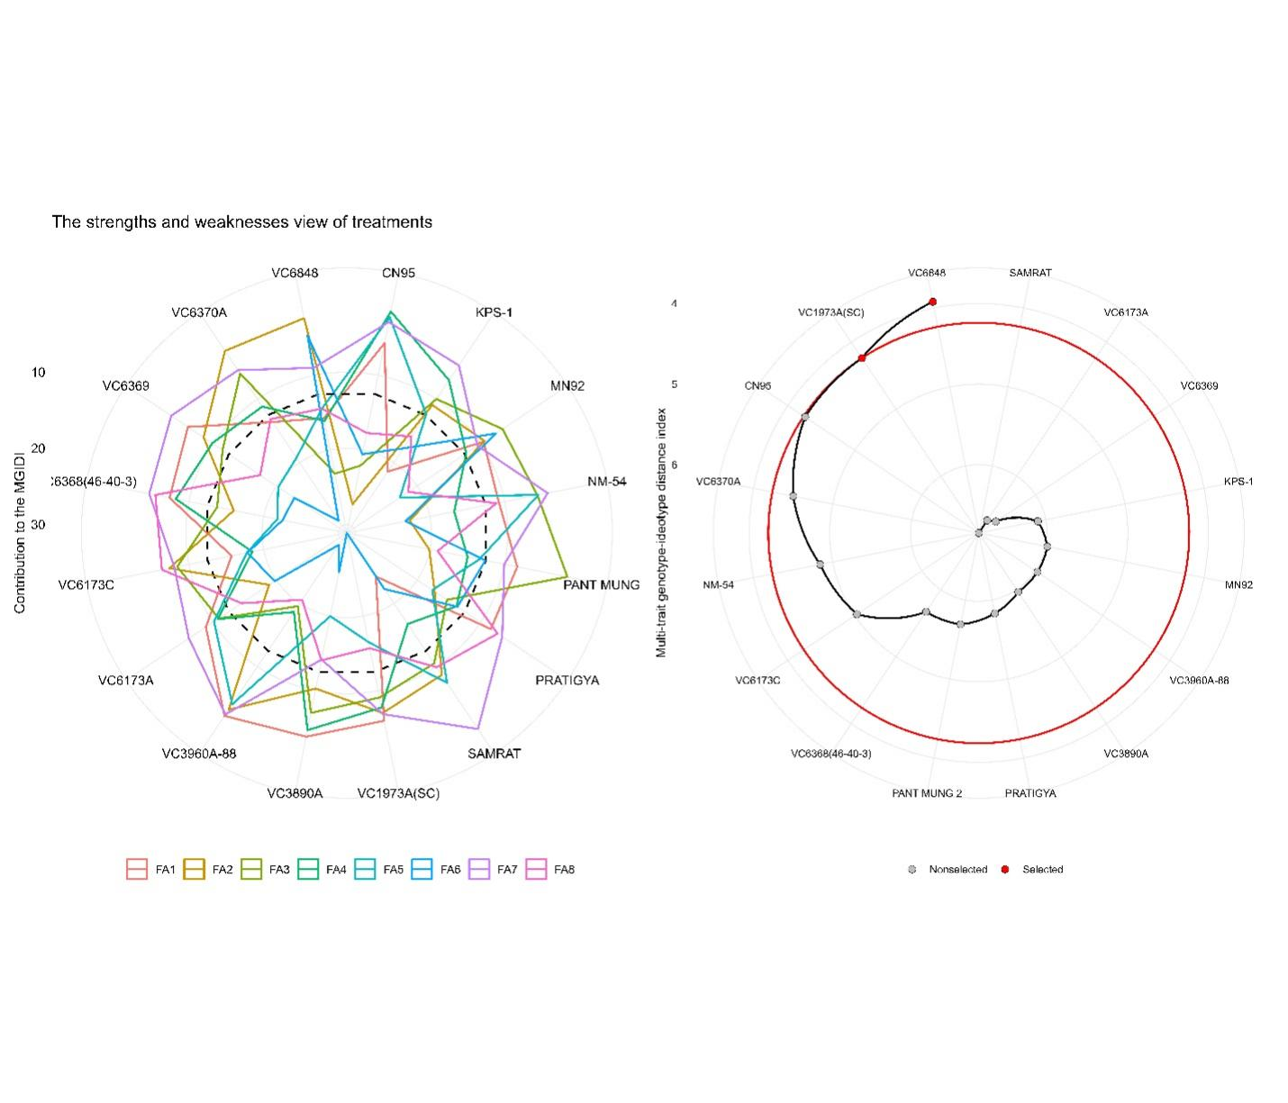

Figure 16 Strength and Weakness among the genotypes and MTSI selected genotype indicated by red dot on Heat map

1. **Discussion**

To keep improving mung-bean varieties over time, researchers need to study reliable sources of important quality traits. Compared to other multivariate techniques such as the PCA bi-plot, cluster analysis is more effective in grouping genotypes into homogeneous subsets, which can help identify diverse parents or genotypes for use in breeding or other research programs[30]. This is because cluster analysis can identify genotypes that are similar to each other across a wide range of traits, while the PCA biplot is more focused on identifying the most important traits that contribute to the overall variation in the data for the particular Genotypes. Cluster analysis can also help to bring together genotypes with desirable traits, which can minimize the number of generations needed to develop new varieties with improved performance[31]. In Nepal, where more than three-quarters of mung-bean is grown in rainfed conditions, the Multi Trait Stability Index (MTSI) is a valuable tool for identifying rapeseed genotypes that are resistant to water stress[32]. These genotypes can then be used in breeding programs to develop superior mung-bean varieties for rainfed conditions. Utilizing a multi-trait stability index enables the selection of lentil varieties that thrive in rainfed environments, ensuring consistent and superior performance across varying environmental conditions[33]. Mung bean breeders, growers, and marketers prioritize a range of mung bean quality parameters, encompassing both vegetative markers and reproductive traits. These traits include flower drops aspects, pod length, number of clusters per plant, number of seeds per pod, seed size, 100-seed weight, harvesting efficiency, and nutritional content. In light of the escalating climate change impacts on Nepal's agricultural landscape, evaluating the stability of promising mung bean genotype across diverse environmental conditions is of paramount importance[34]. Analysis of variance for most of the phenology traits showed significant variation. Qualitative study of the 4 mung bean traits shows that first set of parameters pertains to the color of the hypo-cotyledon, with the majority exhibiting a purple hue (82.5%), followed by green (12.9%) and green with purple tint (2.9%). Additionally, a small percentage showed dark purple or mixed coloration. In terms of terminal leaf shape, the majority exhibited an ovate shape (79.2%), while deltoid lanceolate and lanceolate shapes were observed in 16.7% and 4.2% of the genotypes, respectively. Regarding the position of the racemose, a substantial proportion (73.8%) displayed it above the canopy, while 26.3% showed an intermediate position. Finally, the pod color was predominantly green-purple (62.9%), with 24.6% displaying green pods with purple spots, and 12.5% exhibiting greenish-purple pods. Similar study shows that Hypocotyl color, stem color, leaf color, calyx color demonstrated moderate phenotypic diversity within the range of 0.50 to 0.75, while the remaining traits exhibited high phenotypic diversity[31][35]. VC6369 and VC3960A-88 demonstrated the highest oven dry weight (ODW) at both 30 and 45 DAS. These findings suggest that genotype VC6370A is better at maintaining water content under drought stress conditions, while genotype VC6368(46-40-3) is more efficient in absorbing water. Another study shows that application of GA3 resulted in the enhancement of various morpho-physiological aspects in mung bean, including water-related parameters (RWC, WSD, WRC, and WUC), as well as characteristics contributing to growth and yield[22]. The investigation revealed a significant correlation between field secondary roots and field root-to-shoot ratio (r = 0.29, p < 0.001) as well as field root length (r = 0.37, p < 0.001). This implies a crucial role of field secondary roots in influencing the growth and development of mung bean seedlings in field conditions. Moreover, a strong positive correlation was observed between field root-to-shoot ratio and field root length (r = 0.85, p < 0.001), indicating an allocation of more resources to root growth in response to the potentially stressful field conditions. Interestingly, field shoot length displayed a negative correlation with field root-to-shoot ratio (r = -0.50, p < 0.001), suggesting a strategic resource allocation by mung bean seedlings in favor of enhanced root development under challenging field conditions. The research revealed a robust positive correlation between plant height at 30 and 45 days after sowing (DAS) and straw yield per hectare (SY.Ha), biological yield per hectare (B.Ha), and harvesting index (HI) (p < 0.001, r = 0.26 to 0.34). This indicates that increased plant height is associated with higher yields. Furthermore, there was a significant positive correlation between trifoliate leaf number at 30 and 45 DAS and plant height, biological yield, and harvesting index (p < 0.05, r = 0.13 to 0.15). A similar result was observed by Ref[24]. In this investigation, nine traits were identified as significant contributors to grain yield in the first dimension. These traits include 45-day plant length (X45PH), number of clusters per plant (NCCP), 100-grain weight (X100GSW), grain yield per hectare (GY.ha), harvesting index (HI), plot yield, sample plant yield (Y.PSP), straw yield per hectare (SY.Ha), and biological yield per hectare (B.ha). Among these, B.ha exhibited the highest contribution factor for dimension one. Dimension two comprised six traits associated with yield: white portion below ground (BGWP), diameter of seed (DoS), seed number per pod (NSPP), 45 DAS effective number of nodules (X45.ENN), length of seed (LOS), and area of seed (AOS), along with 30 DAS nodules and effective number of nodules, this finding is consistence with [36]–[38]. The 100-grain seed weight, as a quantitative attribute, shows a stronger correlation with the light green square legend cluster, comprising genotypes 'Samrat' and 'KPS'. Similarly, other yield attributes like grain yield, harvesting index, pod length, biological yield, straw yield, and number of clusters per plant are primarily clustered in the plus sign legend cluster. This particular cluster includes genotypes such as 'CN95', 'VC6173A', and various other VC accessions. The findings of this study are in line with the results of a previous study that used PCA and path coefficient analysis to investigate the relationship between groundnut yield and grain quality attributes[39]. The Multi-Trait Stability Index indicates that three genotypes, namely VC6848, VC1973A, and CN95, have been recognized as the optimal genetic strains for mung bean cultivation. A similar protocol was employed for this assessment[16], [17], [40], [41]. This finding demonstrated a substantial degree of consistency with our original alternate hypothesis. However, more research is needed to address study limitations.

1. **Conclusion:**

The comprehensive evaluation of 16 mung bean genotypes has yielded valuable insights into the traits that govern agronomic performance. Key factors such as secondary roots, effective root nodules, and various yield attributes exhibited strong correlations, underscoring their importance as potential targets for precision breeding to enhance mung bean yield. The analysis of variance revealed significant variations among the yield attributes. The application of advanced techniques such as Principal Component Analysis and cluster analysis facilitated the identification of influential components and superior genotypes. Notably, VC1973A and CN95 emerged as stable and high-yielding genotypes, laying a solid foundation for future breeding endeavors. Specific genotypic attributes, such as VC6370A's water retention capacity and VC6368(46-40-3)'s tolerance to stress, highlight unique strengths. The multi-trait stability index emphasized the robust performance of genotypes VC3960A-88, VC3890A, CN95, and VC1973A(SC), positioning them as promising candidates for future breeding initiatives. Moving forward, field evaluations will be essential to validate the adaptability and commercial potential of these genotypes, paving the way for the development of high-yielding and resilient mung bean varieties with desirable agronomic traits.

**AUTHOR CONTRIBUTIONS**

Bikas Basnet: Conceptualization, Investigation; methodology; formal analysis; writing—original proof reading of final draft, Writing—review and editing; visualization; software, Funding acquisition, Supervision.

ACKNOWLEDGEMENTS

first author is thankful to Agriculture and Forestry University for providing land for this study and Grain Legumes Research Program, Khajura, Bake, Nepal for Providing the Germplasm.

Disclosure statement

The authors report there are no competing interests to declare

CONFLICT OF INTEREST STATEMENT

No conflict of interest exists.

DATA AVAILABILITY STATEMENT

The data will be available on request.

**Funds and Grants**

**No funding was received.**

[1] M. Baza, D. Shanka, and M. Bibiso, “Agronomic and economic performance of mung bean (Vigna radiata L.) varieties in response to rates of blended NPS fertilizer in Kindo Koysha district, Southern Ethiopia,” *Open Life Sci.*, vol. 17, no. 1, pp. 1053–1063, 2022, doi: 10.1515/biol-2022-0461.

[2] “2021_Ha et al A near‐complete genome sequence of mungbean Vigna radiata L provides key insights into.pdf.” .

[3] C. Liu *et al.*, “High-quality genome assembly and pan-genome studies facilitate genetic discovery in mung bean and its improvement,” *Plant Commun.*, vol. 3, no. 6, p. 100352, 2022, doi: 10.1016/j.xplc.2022.100352.

[4] Y. J. Kang *et al.*, “Genome sequence of mungbean and insights into evolution within Vigna species,” *Nat. Commun.*, vol. 5, 2014, doi: 10.1038/ncomms6443.

[5] K. D. Joshi *et al.*, “Regulatory reform of seed systems: Benefits and impacts from a mungbean case study in Nepal,” *F. Crop. Res.*, vol. 158, pp. 15–23, 2014, doi: 10.1016/j.fcr.2013.12.011.

[6] P. K. Dahiya, A. R. Linnemann, M. A. J. S. Van Boekel, N. Khetarpaul, R. B. Grewal, and M. J. R. Nout, “Mung Bean: Technological and Nutritional Potential,” *Crit. Rev. Food Sci. Nutr.*, vol. 55, no. 5, pp. 670–688, 2015, doi: 10.1080/10408398.2012.671202.

[7] A. Tahir *et al.*, “Selection criteria for yield potential in a large collection of Vigna radiata (L.) accessions,” *Euphytica*, vol. 216, no. 9, pp. 1–12, 2020, doi: 10.1007/s10681-020-02675-x.

[8] “j[mlif.”

[9] C. B. A. Andr eacute a, J. da S. Alysson, S. eacute rgio F. Ant ocirc nio, H. U. ecirc da T. Sandra, and O. D. M. Ant ocirc nio, “Strategies for selecting soybean genotypes using mixed models and multivariate approach,” *African J. Agric. Res.*, vol. 11, no. 1, pp. 23–31, 2016, doi: 10.5897/ajar2015.9715.

[10] V. Perić, M. Srebrić, A. Nikolić, and S. Mladenović-Drinić, “Application of multivariate analysis for genotype evaluation in soybean,” *Breed. Grasses Protein Crop. Era Genomics*, pp. 215–219, 2018, doi: 10.1007/978-3-319-89578-9_39.

[11] F. S. Koij and J. Saba, “Using Cluster Analysis and Principal Component Analysis to Group Lines and Determine Important Traits in White Bean,” *Procedia Environ. Sci.*, vol. 29, no. Agri, pp. 38–40, 2015, doi: 10.1016/j.proenv.2015.07.145.

[12] K. Mafakheri, M. R. Bihamta, and A. R. Abbasi, “Assessment of genetic diversity in cowpea (Vigna unguiculata L.) germplasm using morphological and molecular characterisation,” *Cogent Food Agric.*, vol. 3, no. 1, 2017, doi: 10.1080/23311932.2017.1327092.

[13] E. Carrillo-Perdomo *et al.*, “Development of new genetic resources for faba bean (Vicia faba L.) breeding through the discovery of gene-based SNP markers and the construction of a high-density consensus map,” *Sci. Rep.*, vol. 10, no. 1, pp. 1–14, 2020, doi: 10.1038/s41598-020-63664-7.

[14] A. M. Zuffo, F. Steiner, J. G. Aguilera, P. E. Teodoro, L. P. R. Teodoro, and A. Busch, “Multi-trait stability index: A tool for simultaneous selection of soya bean genotypes in drought and saline stress,” *J. Agron. Crop Sci.*, vol. 206, no. 6, pp. 815–822, 2020, doi: 10.1111/jac.12409.

[15] A. M. Abdelghany *et al.*, “Exploring the phenotypic stability of soybean seed compositions using multi-trait stability index approach,” *Agronomy*, vol. 11, no. 11, pp. 1–13, 2021, doi: 10.3390/agronomy11112200.

[16] N. K. Benakanahalli *et al.*, “A Framework for Identification of Stable Genotypes Basedon MTSI and MGDII Indexes: An Example in Guar (Cymopsis tetragonoloba L.),” *Agronomy*, vol. 11, no. 6, p. 1221, 2021, doi: 10.3390/agronomy11061221.

[17] D. Taleghani, A. Rajabi, A. Saremirad, and P. Fasahat, “Stability analysis and selection of sugar beet ( Beta vulgaris L .) genotypes using AMMI , BLUP , GGE biplot and MTSI,” *Sci. Rep.*, pp. 1–14, 2023, doi: 10.1038/s41598-023-37217-7.

[18] M. P. Neupane, H. Musalman, and S. K. Sah, “Influence of Sowing Date on Phenology, Biometric, and Yield of Mungbean (Vigna radiata) Cultivars in Chitwan, Nepal,” *Int. J. Agron.*, vol. 2023, 2023, doi: 10.1155/2023/8927439.

[19] N. Shukla, H. Kuntal, A. Shanker, and S. N. Sharma, “Hydro-Priming Methods for Initiation of Metabolic Process and Synchronization of Germination in Mung Bean (Vigna Radiata L.) Seeds,” *J. Crop Sci. Biotechnol.*, vol. 21, no. 2, pp. 137–146, 2018, doi: 10.1007/s12892-018-0017-0.

[20] J. Markwell, J. C. Osterman, and J. L. Mitchell, “Calibration of the Minolta SPAD-502 leaf chlorophyll meter,” *Photosynth. Res.*, vol. 46, no. 3, pp. 467–472, 1995, doi: 10.1007/BF00032301.

[21] Z. Kamarianakis and S. Panagiotakis, “Design and Implementation of a Low-Cost Chlorophyll Content Meter,” *Sensors*, vol. 23, no. 5, 2023, doi: 10.3390/s23052699.

[22] M. S. Islam *et al.*, “Water relations and yield characteristics of mungbean as influenced by foliar application of gibberellic acid (GA3),” *Front. Ecol. Evol.*, vol. 11, no. January, 2023, doi: 10.3389/fevo.2023.1048768.

[23] A. Schneider, G. Hommel, and M. Blettner, “Lineare regressionsanalyse - Teil 14 der serie zur bewertung wissenschaftlicher publikationen,” *Dtsch. Arztebl.*, vol. 107, no. 44, pp. 776–782, 2010, doi: 10.3238/arztebl.2010.0776.

[24] R. Bam, S. R. Mishra, S. Khanal, P. Ghimire, and S. Bhattarai, “Effect of biofertilizers and nutrient sources on the performance of mungbean at Rupandehi, Nepal,” *J. Agric. Food Res.*, vol. 10, no. October, p. 100404, 2022, doi: 10.1016/j.jafr.2022.100404.

[25] C. M. Donald and J. Hamblin, “The Biological Yield and Harvest Index of Cereals as Agronomic and Plant Breeding Criteria,” *Adv. Agron.*, vol. 28, no. C, pp. 361–405, 1976, doi: 10.1016/S0065-2113(08)60559-3.

[26] T. Olivoto and M. Nardino, “Genetics and population analysis MGIDI : toward an effective multivariate selection in biological experiments,” vol. 37, no. December 2020, pp. 1383–1389, 2021, doi: 10.1093/bioinformatics/btaa981.

[27] A. Pour-Aboughadareh and P. Poczai, “Dataset on the use of MGIDI index in screening drought-tolerant wild wheat accessions at the early growth stage,” *Data Br.*, vol. 36, 2021, doi: 10.1016/j.dib.2021.107096.

[28] E. O. Ajayi *et al.*, “We are IntechOpen , the world ’ s leading publisher of Open Access books Built by scientists , for scientists TOP 1 %,” *Intech*, vol. 11, no. tourism, p. 13, 2016, [Online]. Available: https://www.intechopen.com/books/advanced-biometric-technologies/liveness-detection-in-biometrics.

[29] E. Sondheimer and Z. I. Kertesz, “Anthocyanin Pigments,” *Anal. Chem.*, vol. 20, no. 3, pp. 245–248, 1948, doi: 10.1021/ac60015a017.

[30] T. Zhao, X. Meng, C. Chen, L. Wang, X. Cheng, and W. Xue, “Agronomic Traits, Fresh Food Processing Characteristics and Sensory Quality of 26 Mung Bean (Vigna radiata L.) Cultivars (Fabaceae) in China,” *Foods*, vol. 11, no. 12, 2022, doi: 10.3390/foods11121687.

[31] M. G. Azam *et al.*, “Genetic Analyses of Mungbean [Vigna radiata (L.) Wilczek] Breeding Traits for Selecting Superior Genotype(s) Using Multivariate and Multi-Traits Indexing Approaches,” *Plants*, vol. 12, no. 10, 2023, doi: 10.3390/plants12101984.

[32] Z. Li and W. Wu, “Genotype recommendations for high performance and stability based on multiple traits selection across a multi-environment in rapeseed,” vol. 145, no. June 2022, 2023.

[33] M. H. Sellami, C. Pulvento, and A. Lavini, “Selection of suitable genotypes of lentil (Lens culinarismedik.) under rainfed conditions in south italy usingmulti-trait stability index (mtsi),” *Agronomy*, vol. 11, no. 9, 2021, doi: 10.3390/agronomy11091807.

[34] M. Huppertz *et al.*, “Exploring the Potential of Mung Bean: Sustainability and Genomics in a Changing 2 World 3.”

[35] K. Tripathi *et al.*, “Understanding genetic variability in the mungbean ( Vigna radiata L .) genepool,” no. November 2019, pp. 1–12, 2020, doi: 10.1111/aab.12624.

[36] W.-P. Félicien Marie Serge Zida, T. B. Joseph Batieno, T. J. Ouedraogo, and M. Sawadogo, “Agromorphological Evaluation of 44 lines of Mung Bean (Vigna radiata (L.) Wilczek) Introduced in Burkina Faso,” *Eur. Sci. J. ESJ*, vol. 17, no. 40, pp. 20–36, 2021, doi: 10.19044/esj.2021.v17n40p20.

[37] S. Paliwal, S. Sharma, and N. Pathak, “Principal component analysis in mungbean [ Vigna radiata L . Wilczek ] genotypes under two seasons,” vol. 11, no. 3, pp. 1500–1505, 2022.

[38] K. Basnet, N. Adhikari, and M. Pandey, “Multivariate Analysis among the Nepalese and Exotic Mungbean (Vigna Radiata L. Wilczek) Genotypes Based on the Qualitative Parameters,” *Univers. J. Agric. Res.*, vol. 2, no. 5, pp. 147–155, 2014, doi: 10.13189/ujar.2014.020502.

[39] “Principal Component Analysis and Path Coefficient Analysis for Groundnut Yield and Seed Quality Attributes ( Arachis hypogaea L . ),” pp. 1–7, 2023, doi: 10.18805/LR-5075.Submitted.

[40] T. Hussain, Z. Akram, G. Shabbir, A. Manaf, and M. Ahmed, “Saudi Journal of Biological Sciences Identification of drought tolerant Chickpea genotypes through multi trait stability index,” vol. 28, pp. 6818–6828, 2021.

[41] S. Munda, M. Paw, S. Saikia, T. Begum, J. Baruah, and M. Lal, “Stability and selection of trait specific genotypes of Curcuma caesia Roxb.using AMMI, BLUP, GGE, WAAS and MTSI model over three years evaluation,” *J. Appl. Res. Med. Aromat. Plants*, vol. 32, no. November 2022, 2023, doi: 10.1016/j.jarmap.2022.100446.

[42] Hsu, J. (1996). Multiple comparisons: theory and methods. CRC Press.